**WORKING WITH DITA IN OXYGEN BASIC PROFILING AND REUSE STRATEGIES**

**DITA Profiling**

DITA offers support for conditionally profiling content by using profiling attributes. With Oxygen XML Editor, you can define values for the DITA profiling attributes and they can be easily managed to filter content in the published output. You can switch between profile sets to see how the edited content looks like before publishing. The profiling configuration can also be shared between content authors through the project file and there is no need for coding or editing configuration files.

**1. Profiling attributes**

● Profiling means marking blocks of text meant to appear in some renditions of a document, but not in others.

● DITA offers support for conditionally profiling content by using profiling attributes.

● DITA default profiling attributes: @product, @platform, @audience, @rev, @props, and @otherprops. You can also create your own custom profiling attributes.

● For example, you could define a section of a topic that would only be included for a publication related to the Windows platform by adding the @platform profiling attribute

<section platform = “windows”>

**Creating and Editing Profiling Attributes in DITA**

You can filter DITA content or the structure of a document by using profiling attributes or profiling conditions sets

**Defining Profiling Attributes for DITA Content**

To create or edit profiling attributes for filtering DITA content, follow these steps:

1. If you are creating a new attribute, make sure the attribute is already defined in the document DTD or schema before continuing with the procedure.
2. Open the Preferences dialog box (Options> Preferences) and go to Editor > Edit modes > Author > Profiling / Conditional Text > Attributes and Condition Sets.
3. To add new attributes and values, click the New button at the bottom of the Profiling Attributes table. To customize existing attributes and their values, select an attribute and click the Edit button.

**Step Result:** In either case, this opens a Profiling Attribute configuration dialog box where you can define attributes that exist in your schema

* Selecting the profiling settings from drop down

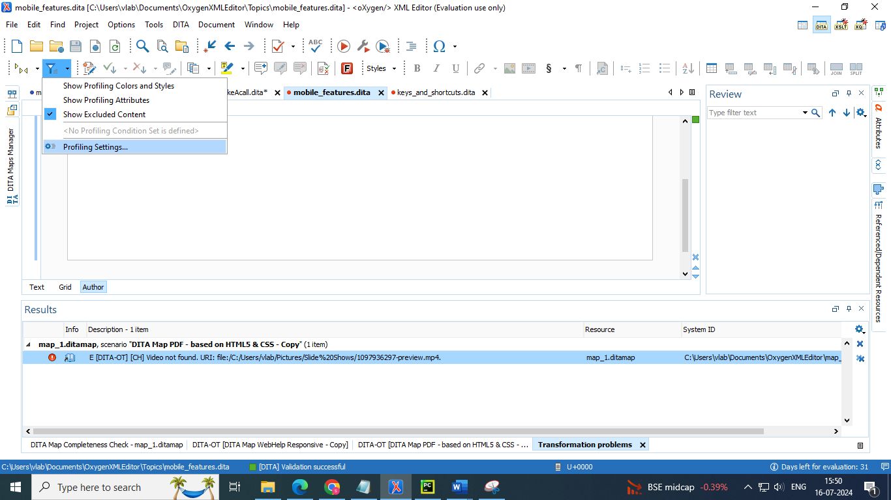

* Preferences dialog box which contains the profiling attributes and their values

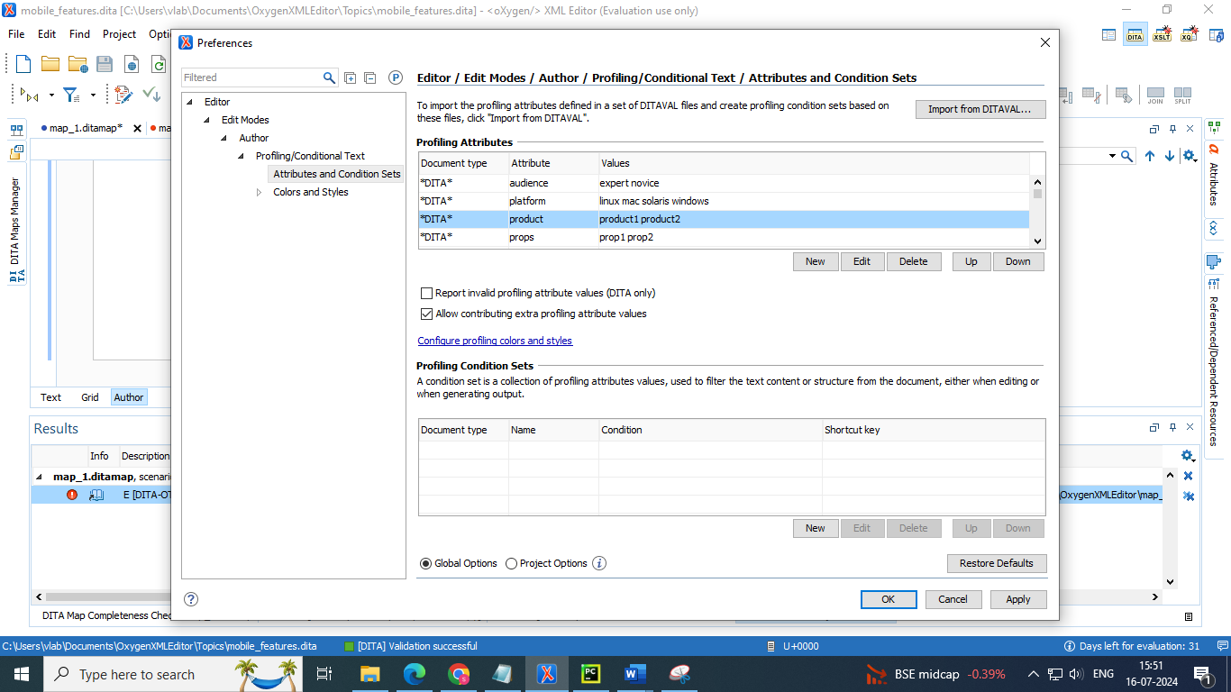

* We can edit add the new profiling attributes and their values By selecting new option to add new attribute or edit option to edit existing attribute

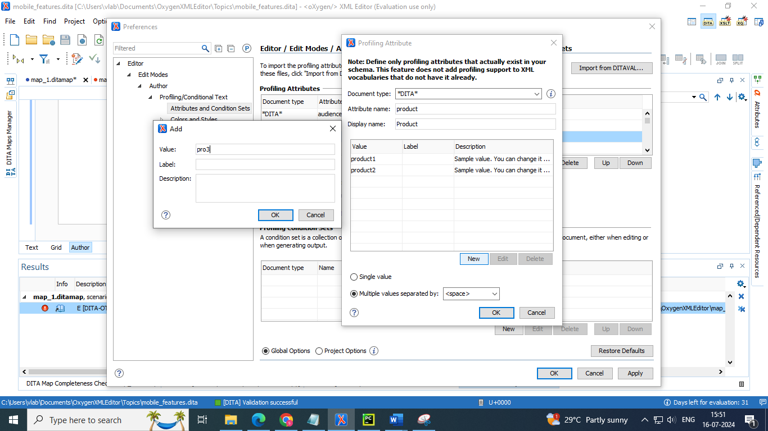

**Customizing Colors and Styles for Rendering Profiling in Author Mode**

By applying profiling colors and styles, you can mark profiled content in Author mode and the DITA Maps Manager so that you can instantly spot differences between multiple variants of the output. This allows you to preview the content that will go into the published output. The excluded text is grayed-out or hidden in Author mode and excluded nodes are grayed-out or hidden in the DITA Maps Manager

Choosing the right style for a specific profiling attribute is a matter of personal taste, but be aware of the following:

• If the same block of text is profiled with two or more profiling attributes, their associated styles combine. Depending on the styling, this might result in an excessively styled content that may prove difficult to read or work with.

• It is recommended that you only profile the differences. There is no need to profile common content, since excessive profiling can visually pollute the document.

• A mnemonic associated with a style will help you instantly spot differences in the types of content

* We can also add colour and styles to profiling attributes

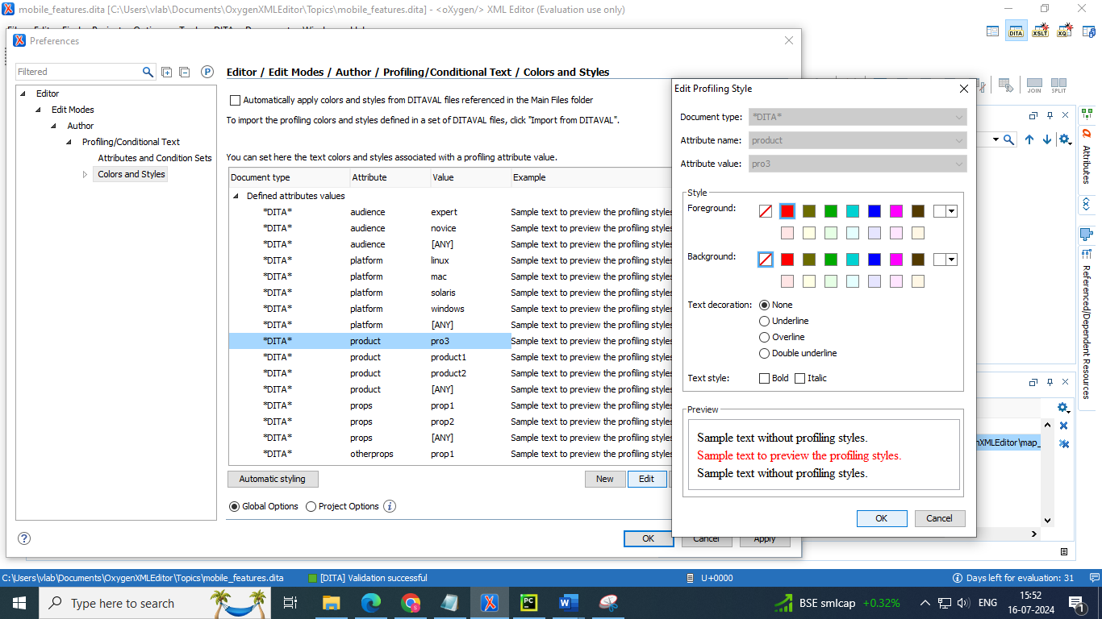

\

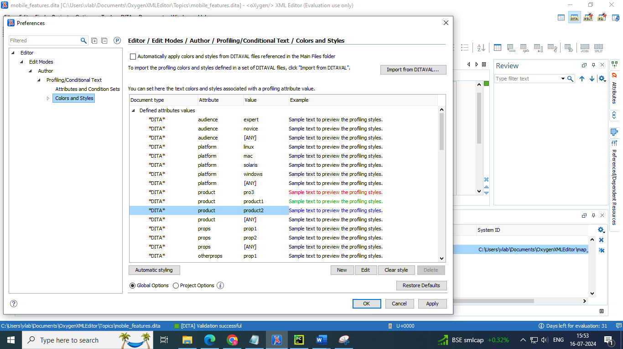

**Applying Profiling Attribute in a Document**

Profiling attributes are applied on element nodes. You can apply profiling attributes on a text fragment (it will automatically be wrapped into a phrase-type element), on a single element, or on multiple elements at the same time. If there is no selection in your document, the profiling attributes are applied on the element at the cursor position.

To profile DITA content in Author mode, highlight the content and select Edit Profiling Attributes from the contextual menu and select the appropriate values in the Edit Profiling Attributes dialog box.

* Go to the line in a topic where you want to add profiling attribute
* Right click 🡪 select edit profiling attributes

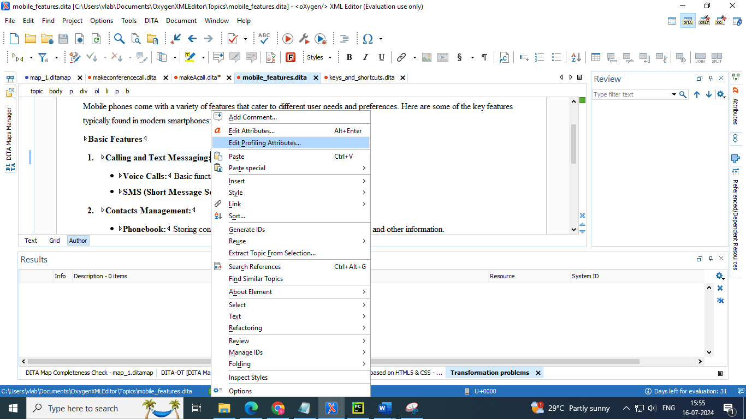

* Select the required attribute you want to add to that line in a topic

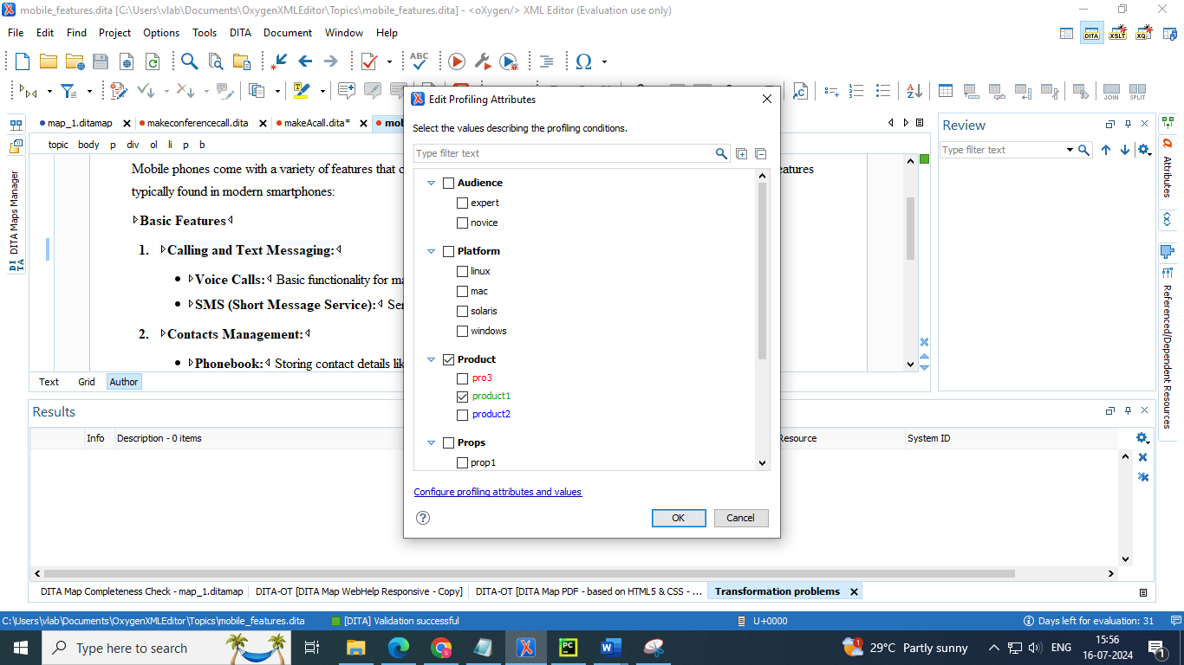

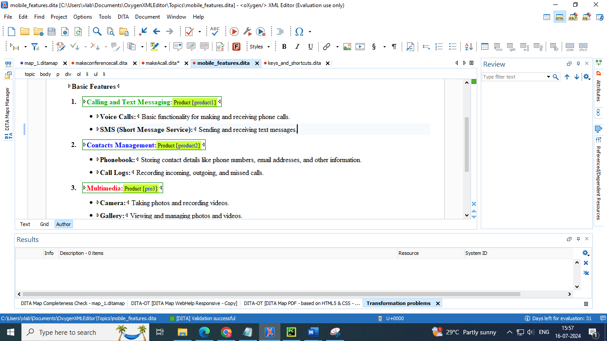

**Applying more than one profiling attribute**

* Select the attribute that is already added to a line
* It gives a drop down of values of attribute you have added
* So we can apply more than one attribute value to a content
* The colour and style will combination of the attributes values applied to that line

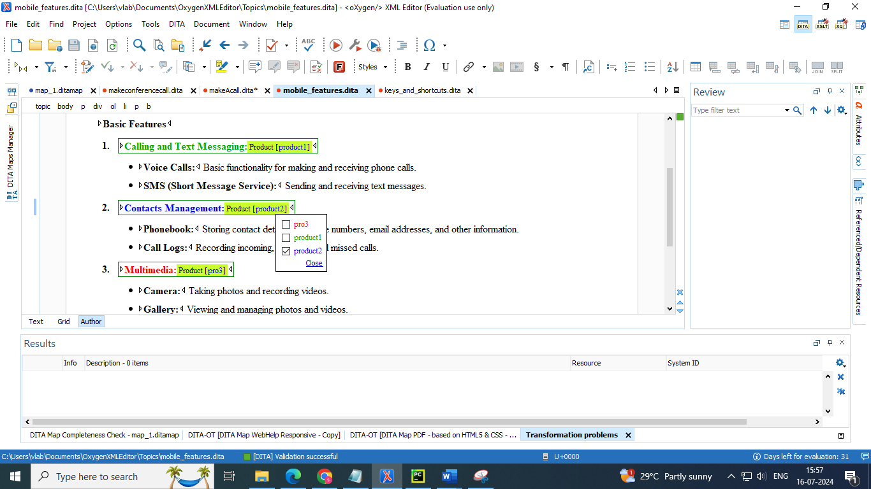

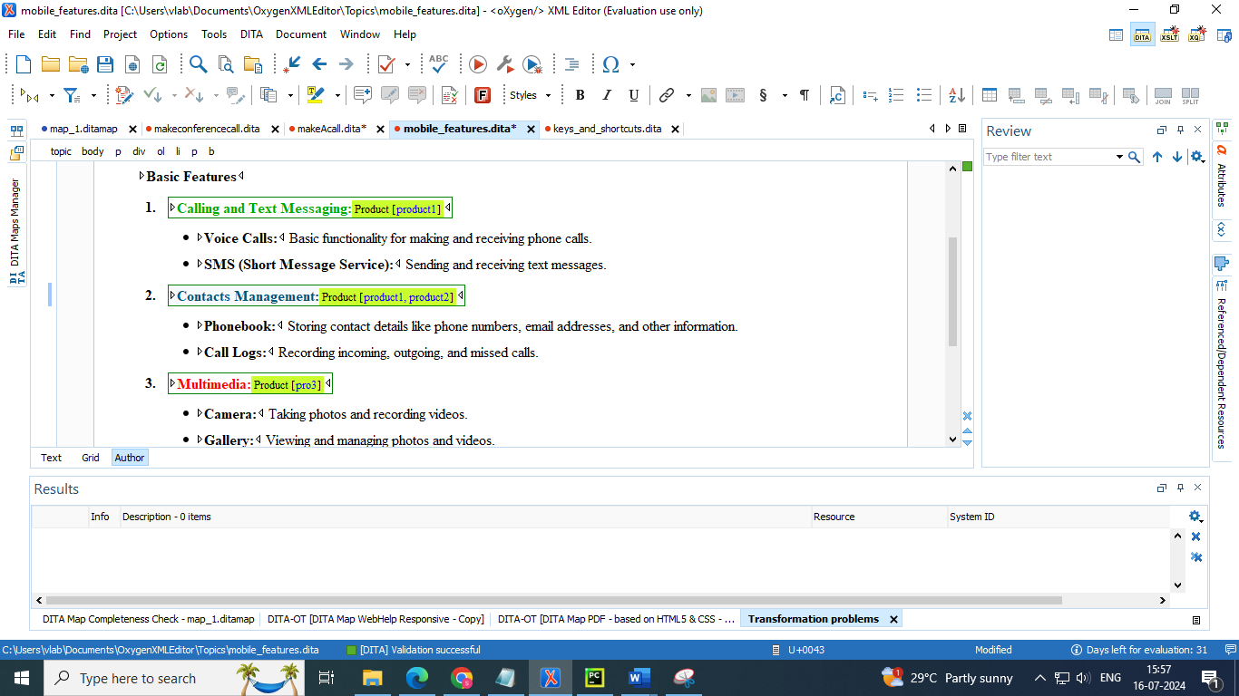

**Completeness check of profiling attributes**

* Enable the checkbox of **“identify possible conflicts between the profiling attributes values”**

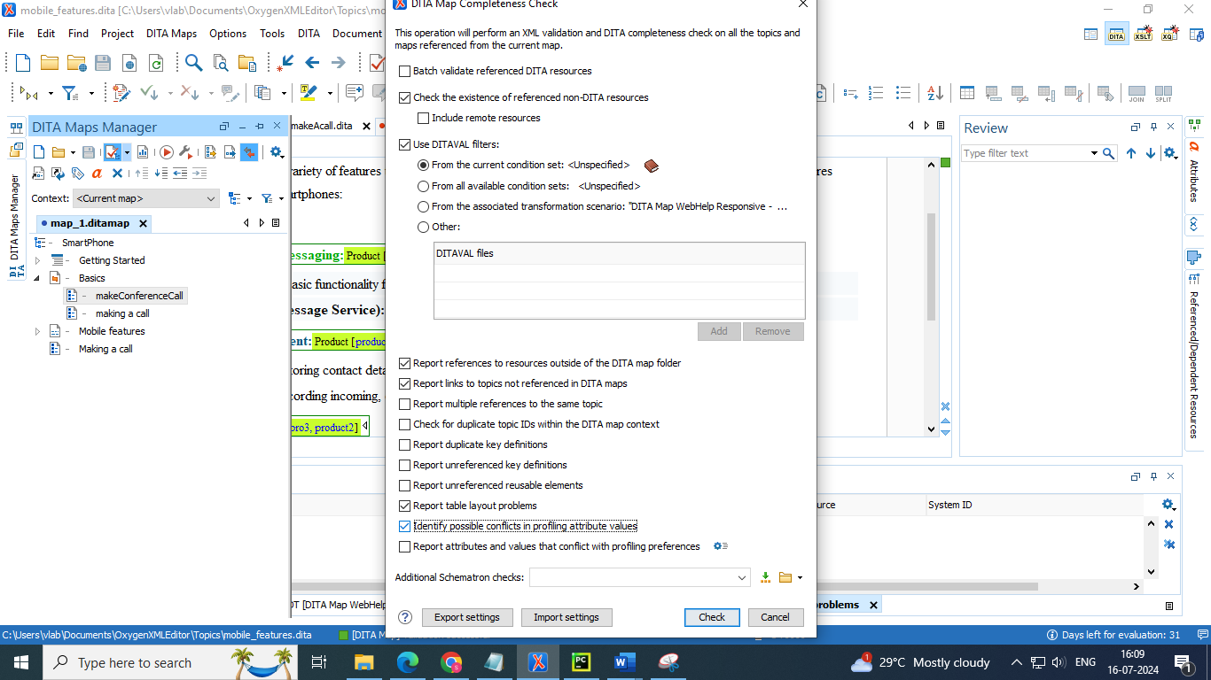

**Applying profiling attributes to the topics**

* Right click on the topic to which you need to add the profiling attributes
* Click edit properties

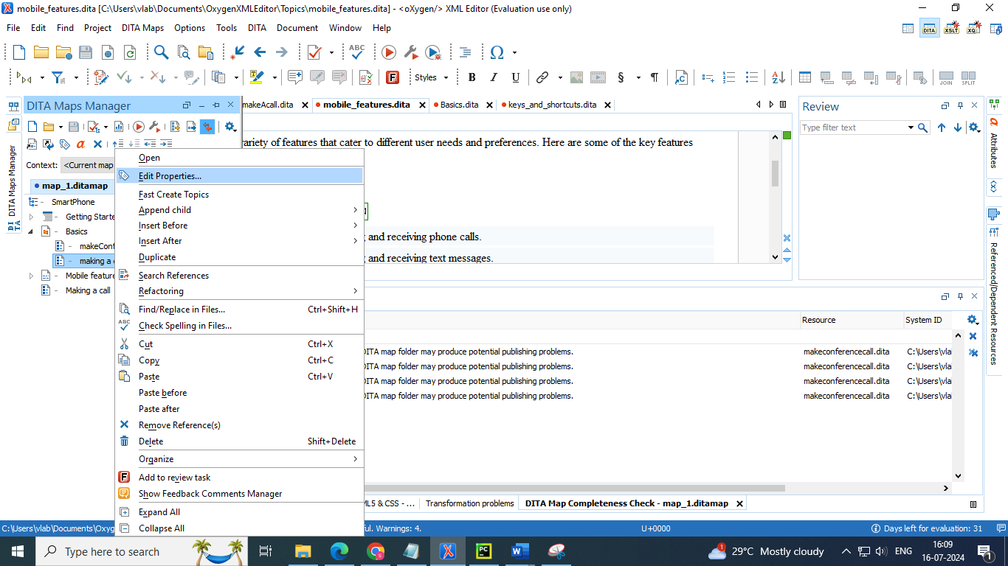

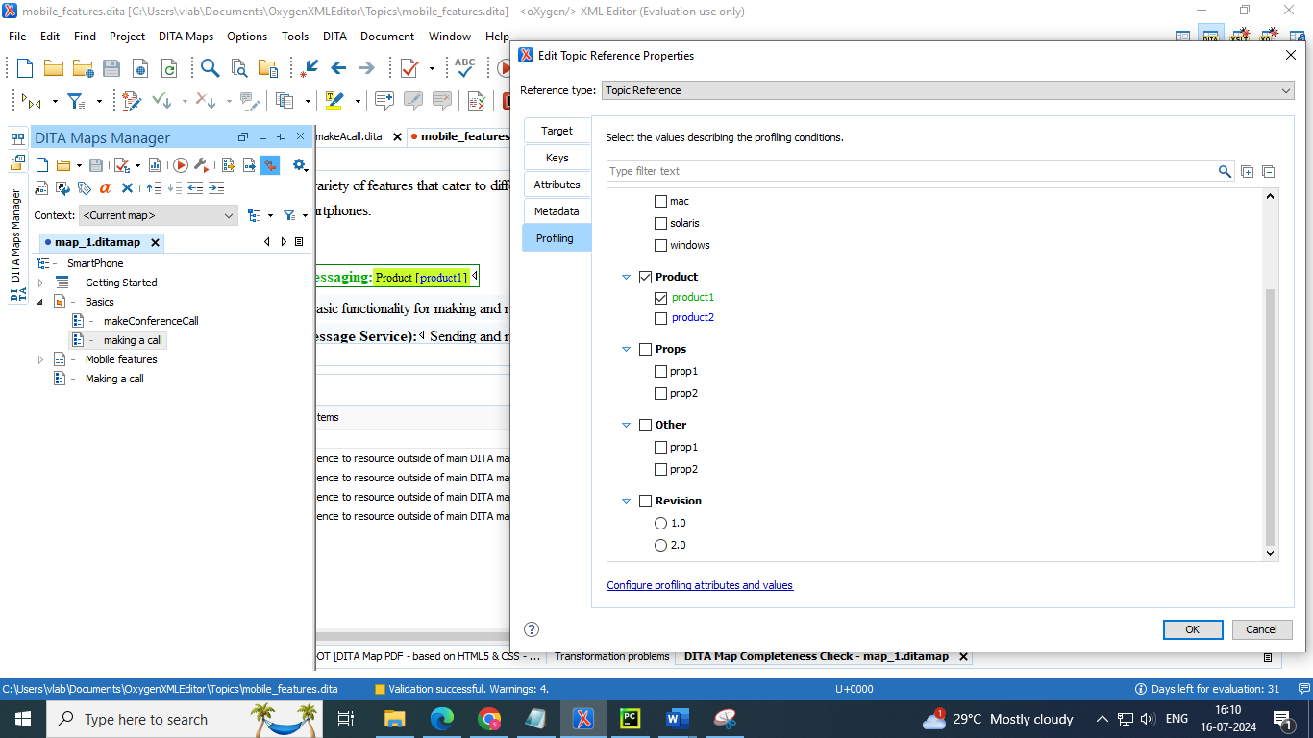

**Profiling Attribute Icons in the DITA Maps Manager**

The following icons are used to mark profiled and non-profiled topics in the DITA Maps Manager:

• - The topic reference contains profiling attributes.

• - The topic reference inherits profiling attributes from an ancestor.

• - The topic reference contains a profiling attribute and inherits profiling from an ancestor.

• (hyphen) - The topic reference neither contains nor inherits profiling attributes.

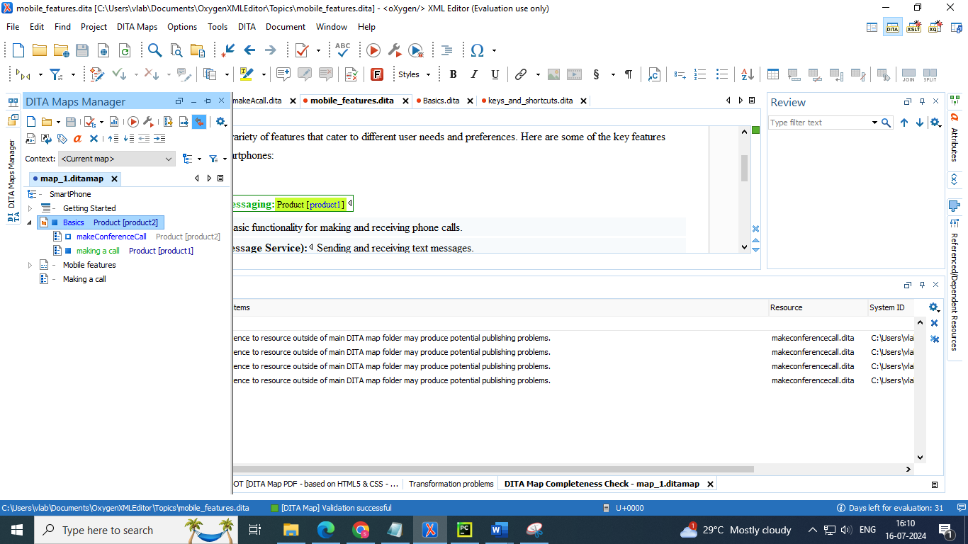

**2. Profiling condition sets**

**Creating and Editing Profiling Condition Sets in DITA**

Multiple profiling attributes can be aggregated into a profiling condition set that allows you to apply more complex filters on the document content. In DITA, profiling conditions can be set within both topics and in maps. When set in a topic, you can filter an element (such as paragraph), step in a procedure, item in a list, or even a phrase within a sentence. When set in a map, you can filter an entire topic or group of topics.

● In Oxygen, a profiling condition = profiling attribute + value.

● Oxygen allows you to aggregate a set of profiling conditions as condition sets (or filters).

● Using profiling condition sets you can:

➢ Preview which topics from a DITA map are included in the output.

➢ Preview which text sections from a topic are included in the output.

➢ Generate filtered output.

To create a new profiling condition set, follow these steps:

1. Open the Preferences dialog box (Options> Preferences) (on page 131) and go to Editor > Edit modes > Author > Profiling/Conditional Text > Attributes and Condition Sets.

2. To add new condition set, click the New button at the bottom of the Profiling Condition Sets table. To customize existing condition sets, select an existing condition set and click the Edit button.

**Step Result:** In either case, this opens a Condition Set configuration dialog box where you can define attributes that exist in your schema.

* Go to profiling settings 🡪 you will observe profiling condition sets below in the dialog box

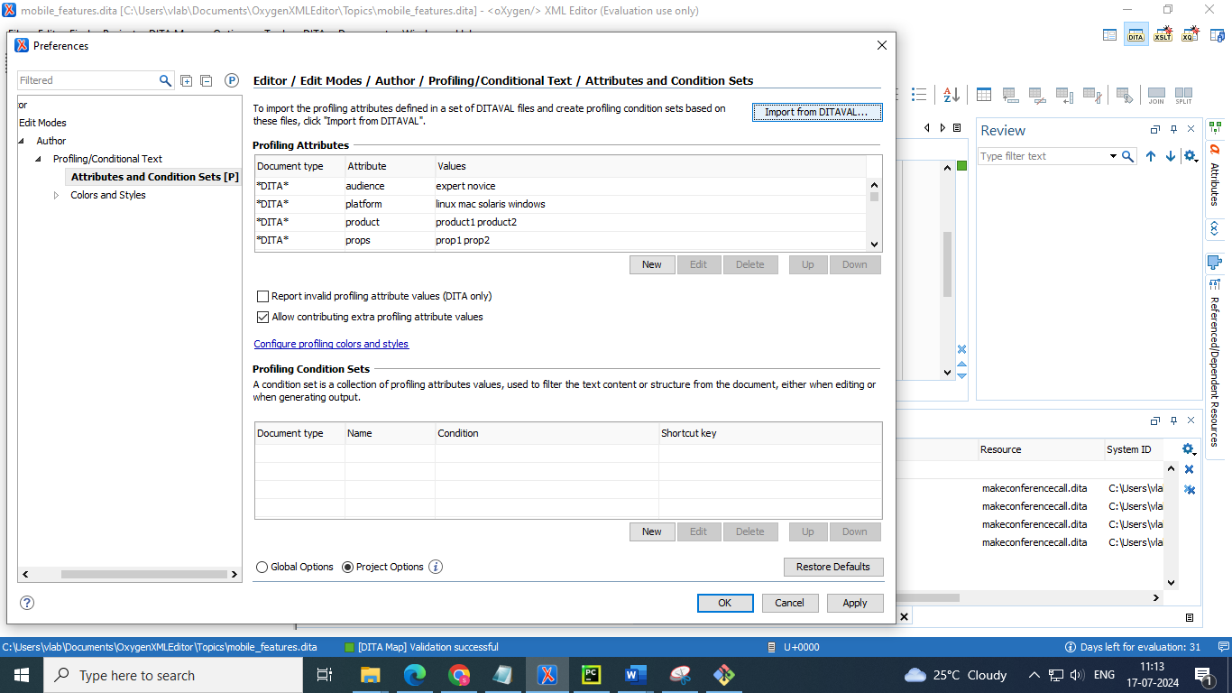

* Select new to add a condition set give a name and select a attribute value to which you want to add the condition set

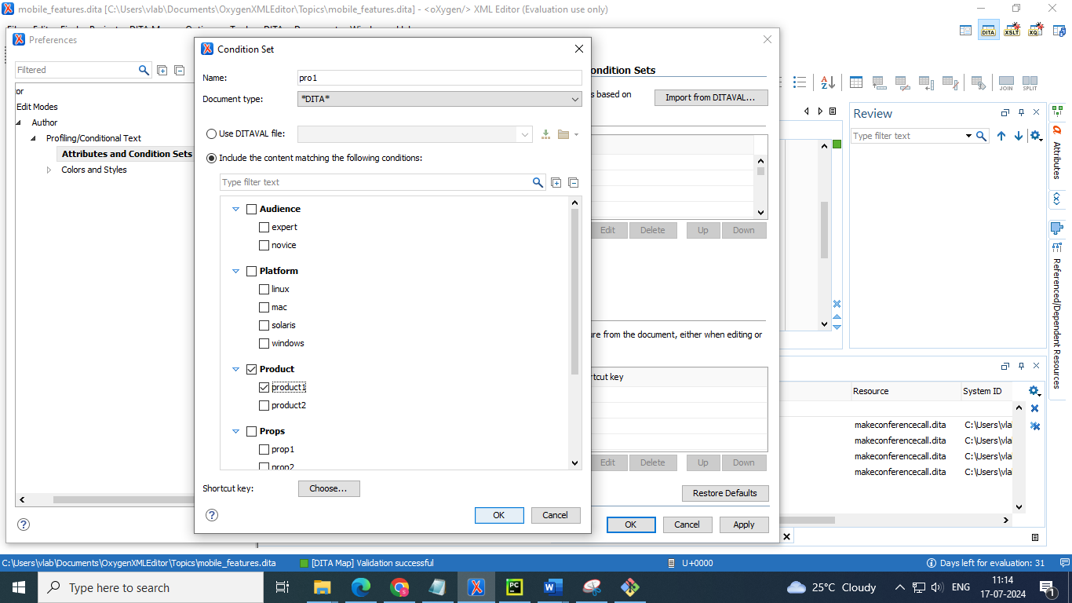

**Applying Profiling Condition Sets in DITA**

All defined Profiling Condition Sets are available as shortcuts in the Profiling / Conditional Text toolbar menu Select a menu entry to apply the condition set. The filtered content is then grayed-out in the Author mode, Outline view and DITA Maps Manager view. Your selection will also be used as the default condition set in transformation scenarios (this can be changed in the Filters tab. An element is filtered-out when one of its attributes is part of the condition set and its value does not match any of the values covered by the condition set

* Select the condition set you have created from the DITA maps manager

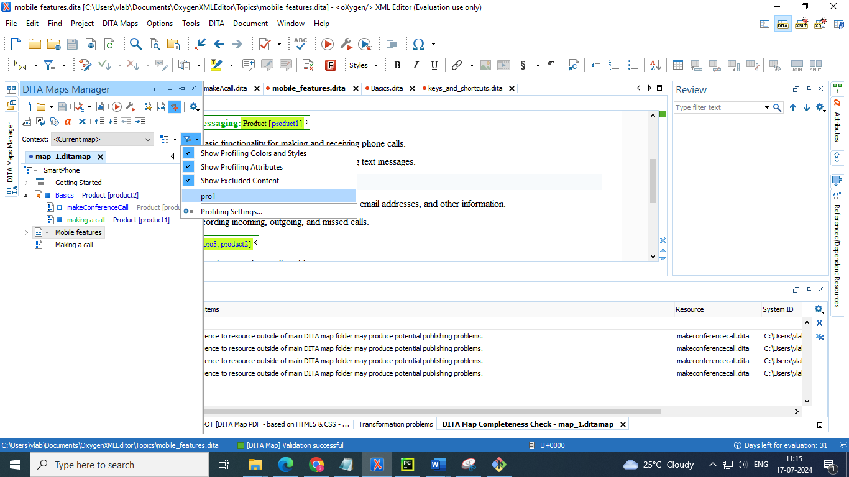

* Excepted the selected condition set of attribute remaining lines having other attributes and topics are grayed out

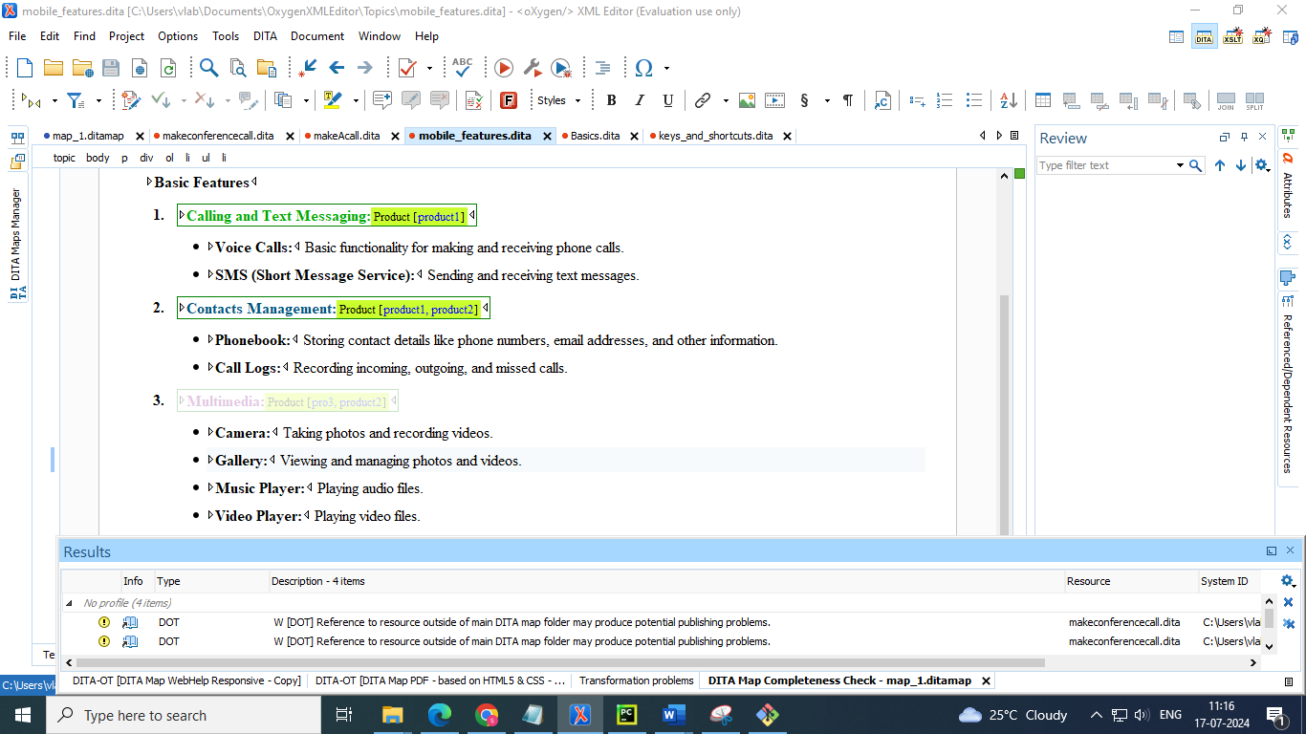

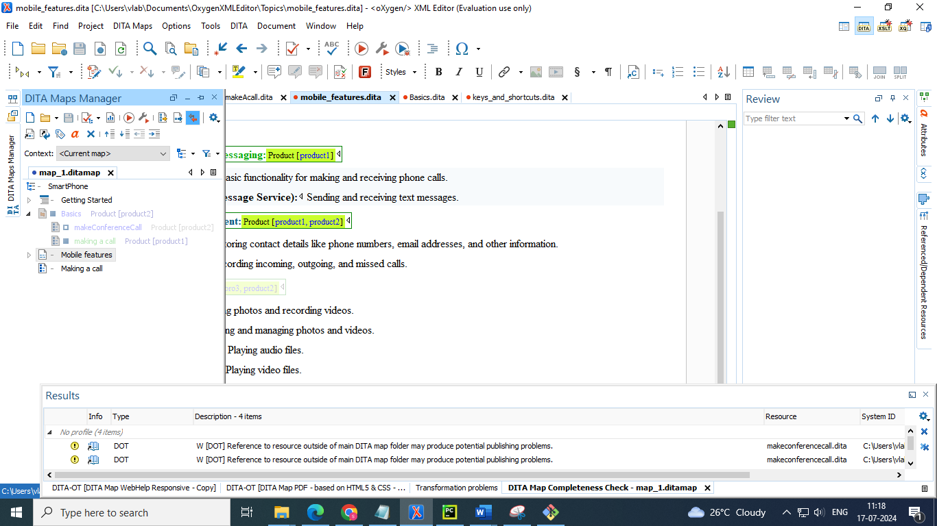

**Showing and Filtering Profiled Content in DITA**

You can visualize the effect of profiling content by using the profiling tools in the Profiling/Conditional Text drop-down menu that is located on the DITA Maps Manager toolbar and on the main toolbar. This drop-down menu includes the following filtering options:

**Show Profiling Colors and Styles**

* Select this option to show colors and styles for profiled content in Author mode and the DITA Maps Manager You can configure the colors and styles or specify whether or not this option is selected by default in the Profiling/Conditional Text > Colors and Styles preferences page

**Show Profiling Attributes**

* Select this option to display the values of the profiling attributes at the end of profiled content in Author mode and next to the nodes in the DITA Maps Manager .You can specify whether or not this option is selected by default in the Profiling/Conditional Text preferences page.

**Show Excluded Content**

* Controls whether the content filtered out by a particular condition set is hidden or grayed-out in Author mode, the DITA Maps Manager and the Outline view. When this option is selected and a condition set is selected in this drop-down menu the filtered content is grayed-out. If this option is not selected and a condition set is selected in this drop-down menu the filtered content is hidden. You can specify whether or not this option is selected by default in the Profiling/Conditional Text preferences page

**Choose Condition Set (Available if more than 15 condition sets are defined)**

* This option is available if you have more than 15 conditions sets defined. It opens a dialog box that makes it easier to find and select condition sets that are not displayed in this drop-down menu.
* Select the show the excluded content 🡪 to view the content that are not in condition set are visible as grayed out

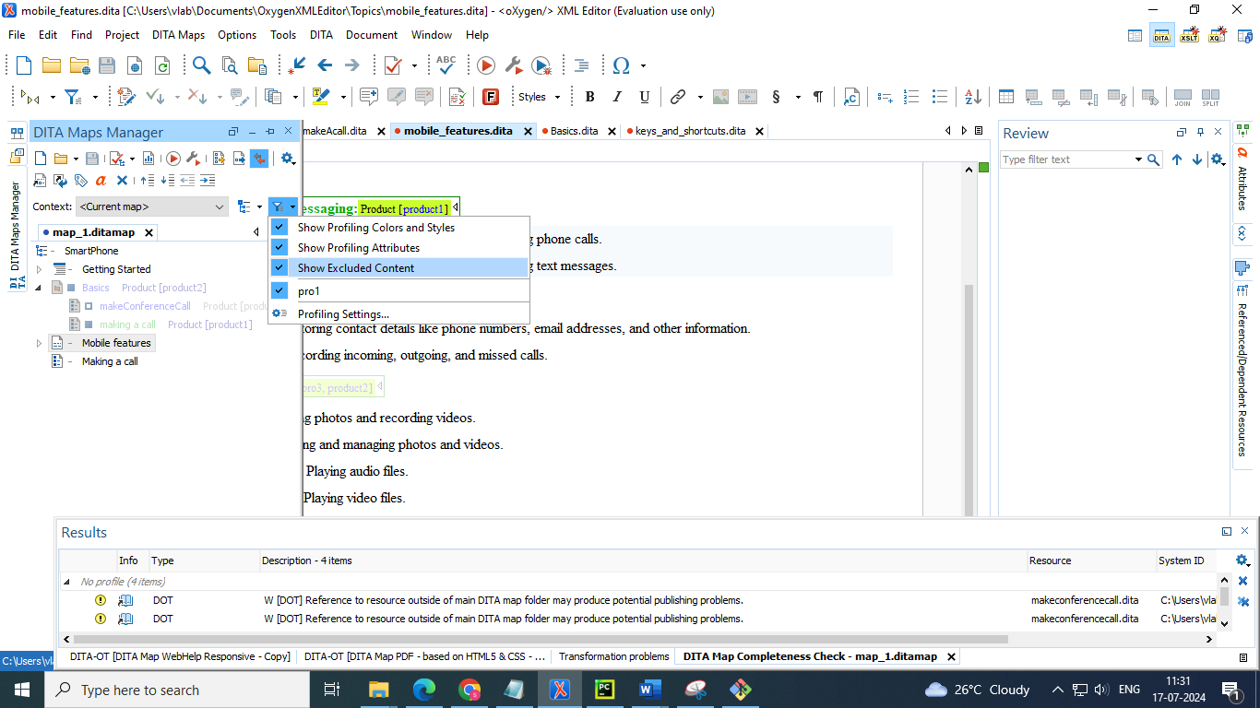

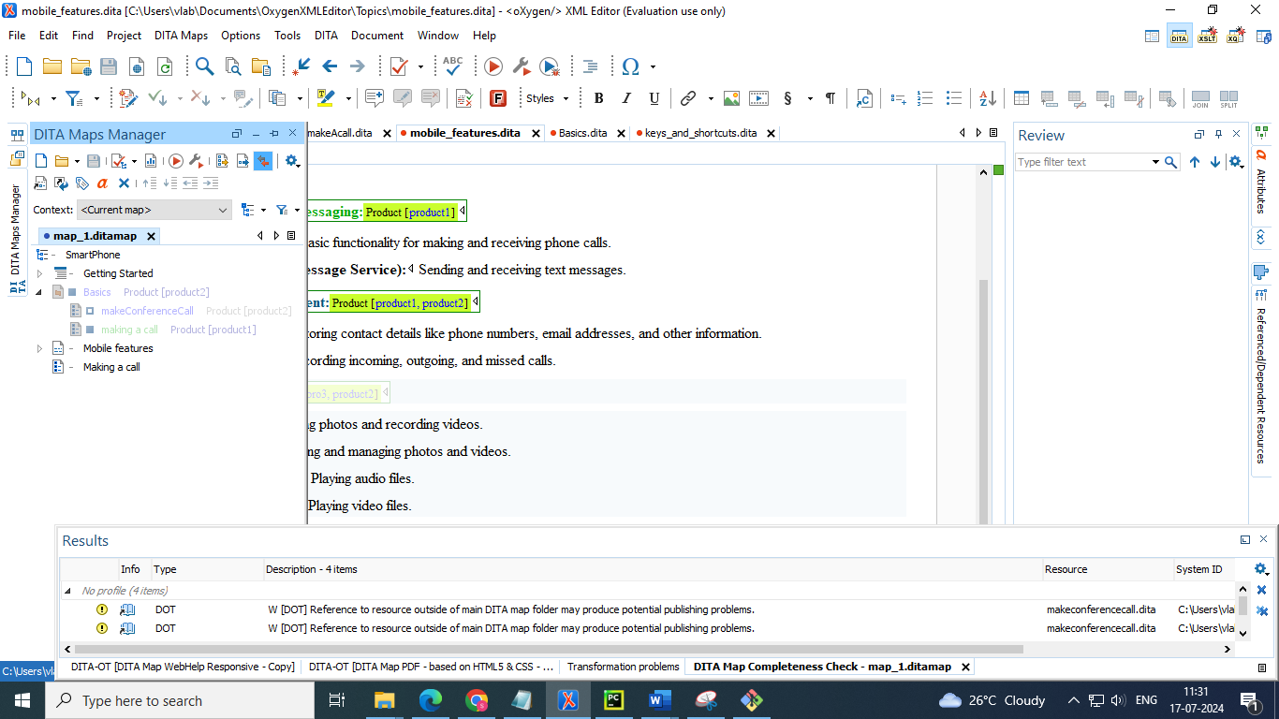

* To remove those grayed out content and make only selected condition data visible 🡪 deselect the “show excluded content”
* It will remove the grayed out topics and lines in those topics

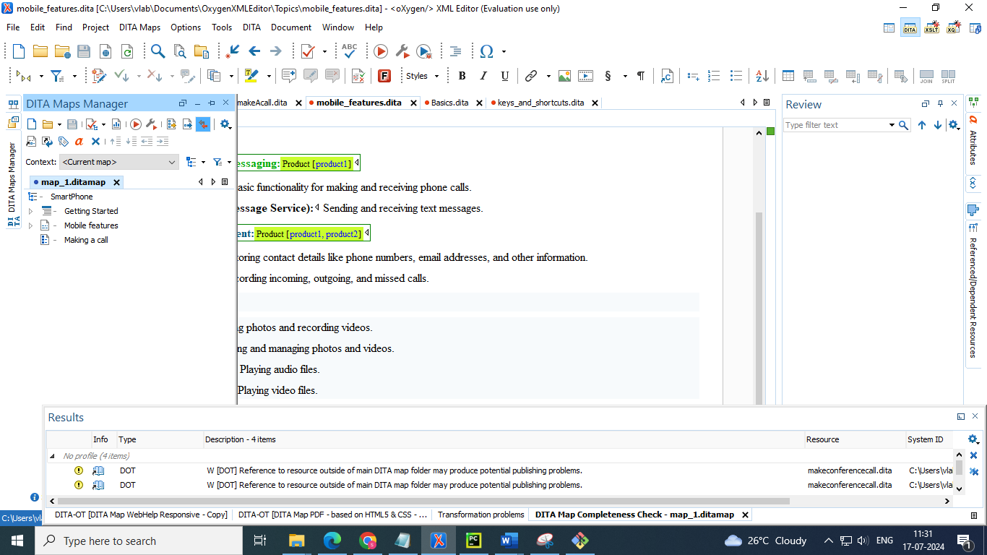

Fig : removes the grayed out topics : Basics

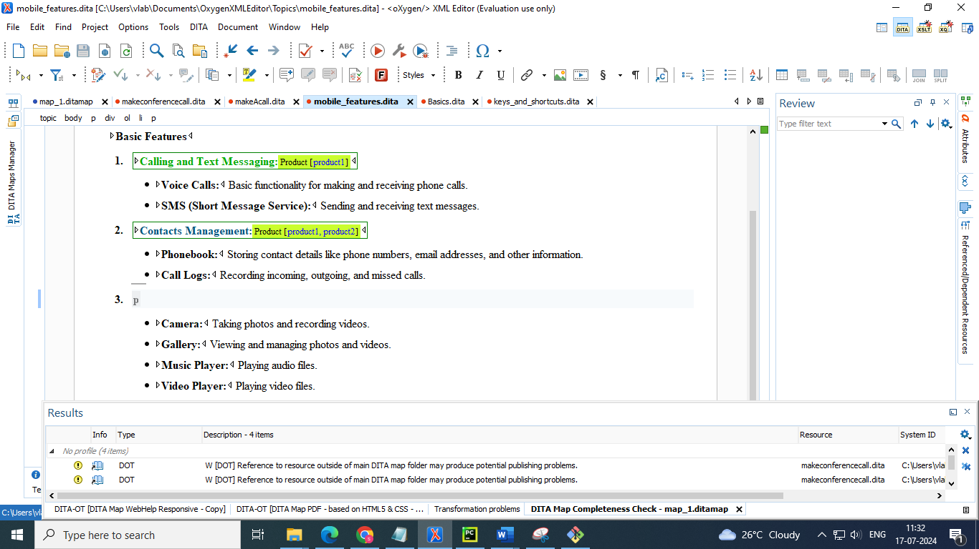

Fig : removed the heading that is grayed out due to condition set

**3. Publishing profiled content**

● DITA-OT uses DITAVAL files to filter the content that is being published.

● A DITAVAL file is an XML file that corresponds to a condition set.

● When publishing, Oxygen automatically creates such files if they are not provided by the user, based on the applied profiling condition sets.

● DITAVAL files can also be used for importing profiling attributes, colors, styles and condition sets into Oxygen's preferences.

**Filtering Profiling Values with a DITAVAL File**

You can use a DITAVAL filter file to control the filtering or flagging of profiled content or to identify which values are to be used for conditional processing during a particular output.

**DITAVAL Filtering Use-Case**

Suppose that a medical publication uses the audience profiling attribute to profile the content for the following types of users: therapist, physician, and surgeon. Suppose that in the output, you want to exclude any content that is profiled as surgeon value for the @audience attribute.

You could use a DITAVAL filter file to exclude anything that is profiled as surgeon:

<?xml version="1.0" encoding="UTF-8"?>  
<val>  
 <prop action="exclude" att="audience" val="surgeon"/>  
</val>

To include a filter file

<?xml version="1.0" encoding="UTF-8"?>  
<val>  
 <prop action="flag" att="audience" val="therapist" color="red"/>  
</val>

**How to Create a DITAVAL Filter File**

To create a DITAVAL filter file, follow these steps:

1. Go to File> New.

2. Scroll to the Framework templates > DITA folder.

3. Select the Filter template file and click Create.

4. Define your filters in the DITAVAL file (in Text or Author mode).

5. Save the DITAVAL file

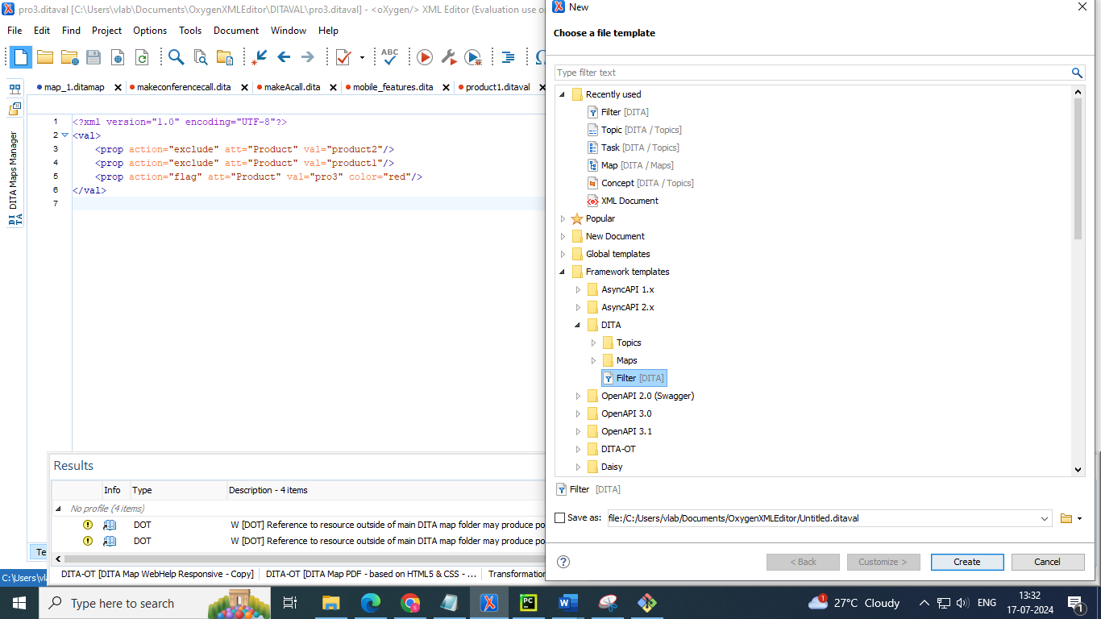

**Styling the Rendering of Profiled Content Using a DITAVAL File**

* You can use the **Import from DITAVAL** option in the Attributes and Condition Sets preferences page to use the DITAVAL file to define profiling attributes.

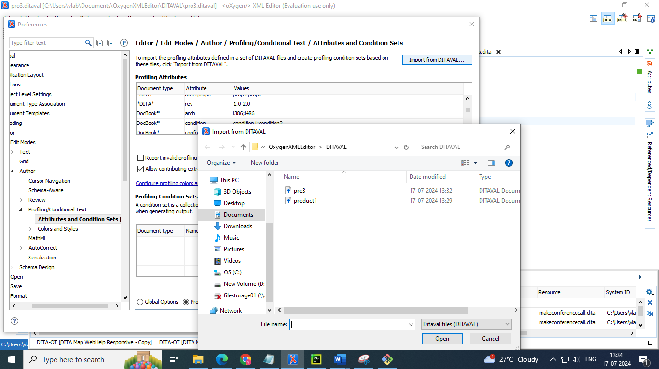

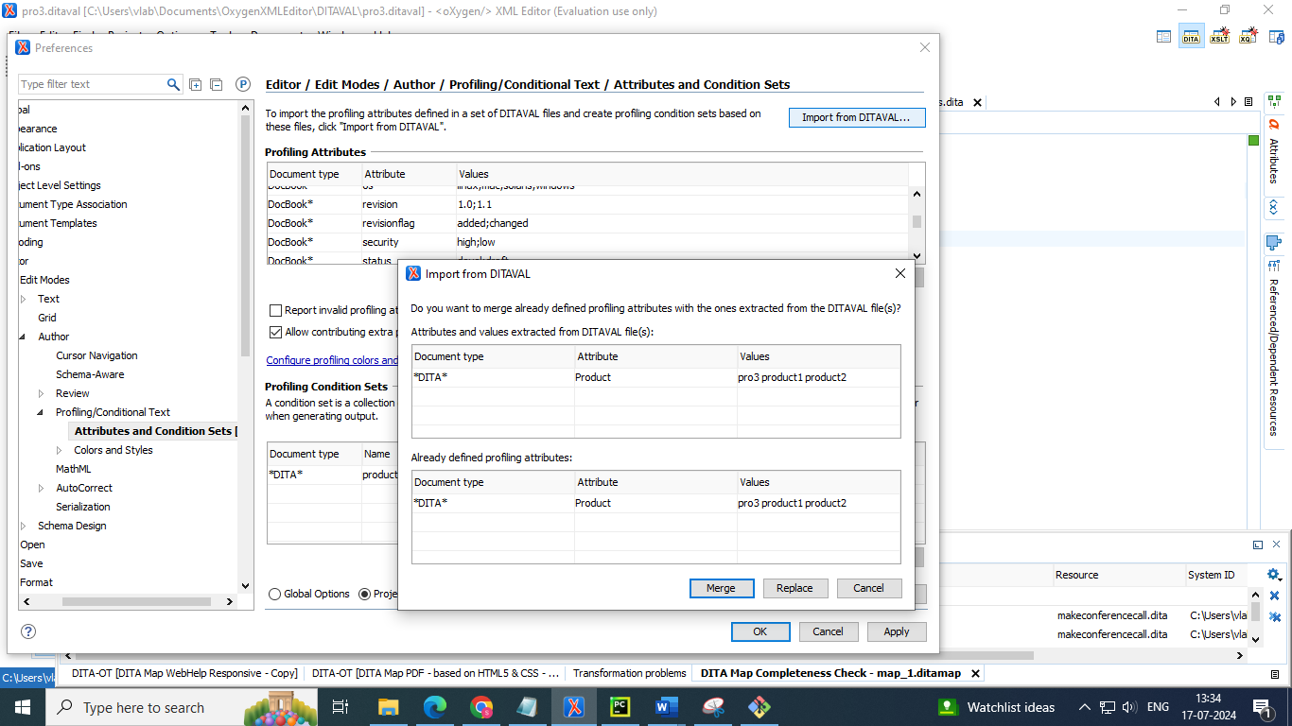

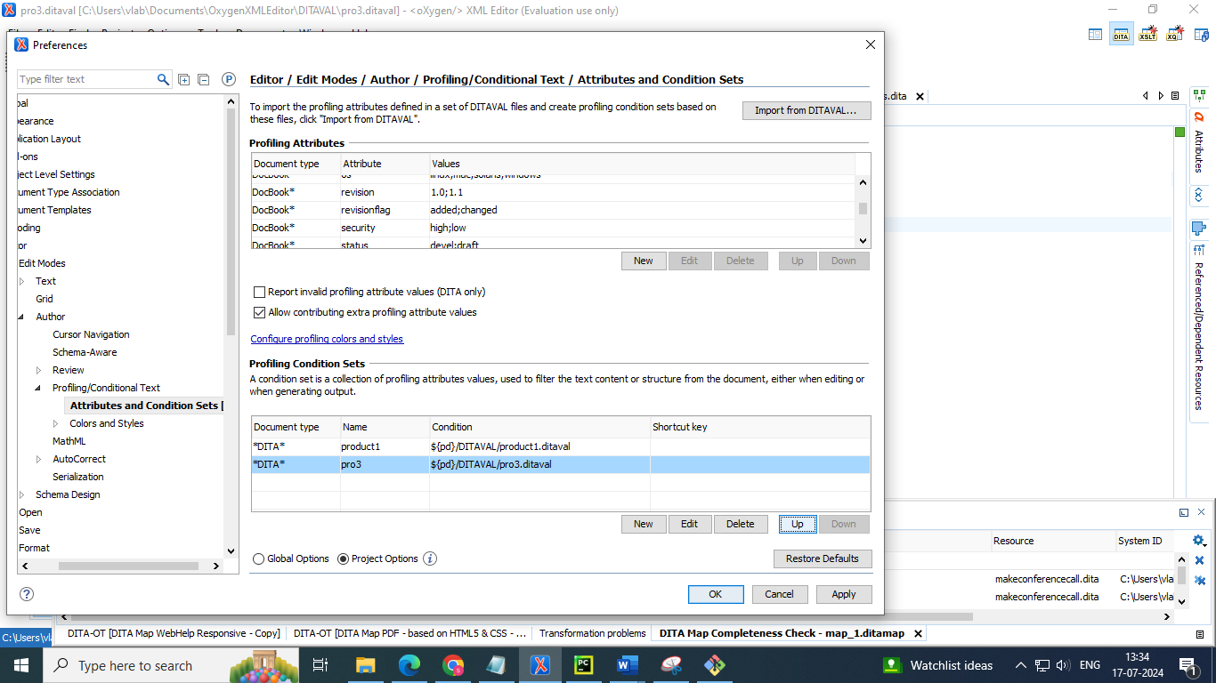

* Also add ditaval files to profiling colours and styles

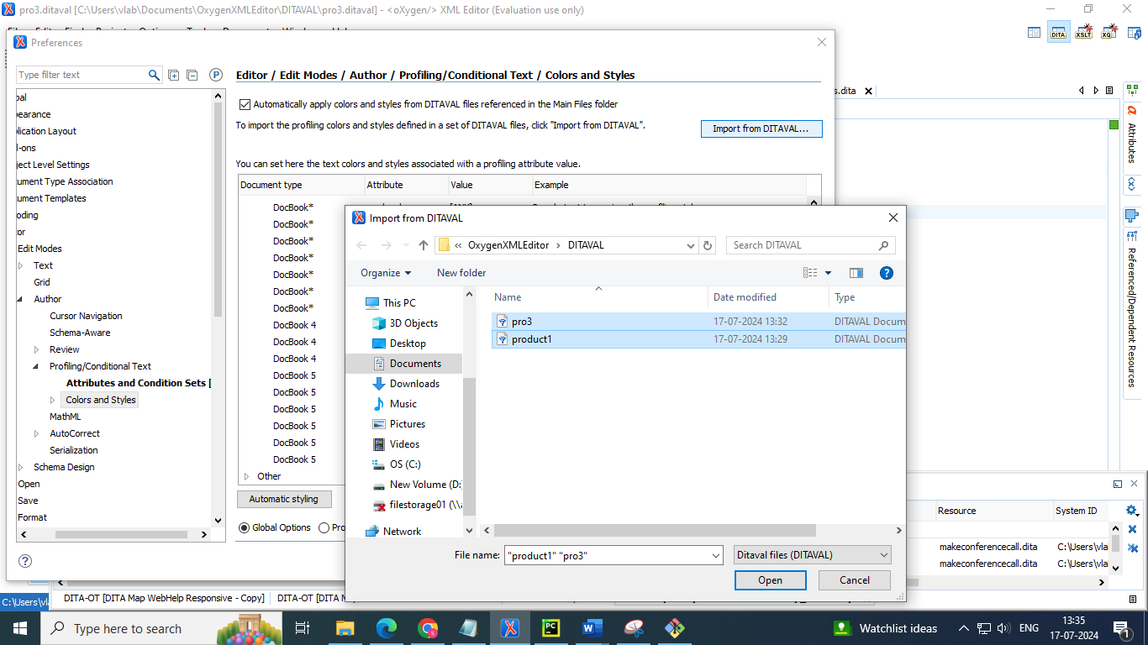

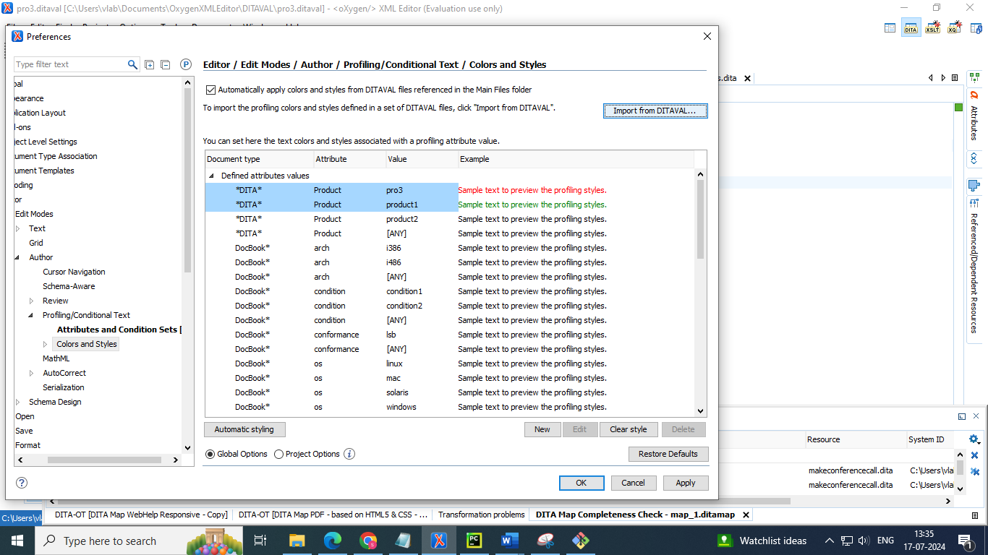

**Publishing Profiled DITA Content**

* You can create a variety of publications or versions of your documentation from a single map by applying profiling conditions to the build.
* Oxygen XML Editor includes preconfigured transformation scenarios for DITA. By default, these scenarios take the current profiling condition set into account during the transformation, as defined in the Filters tab when creating a DITA transformation You can also specify a DITAVAL file that defines filters for your profiled content.
* You can duplicate the DITA map

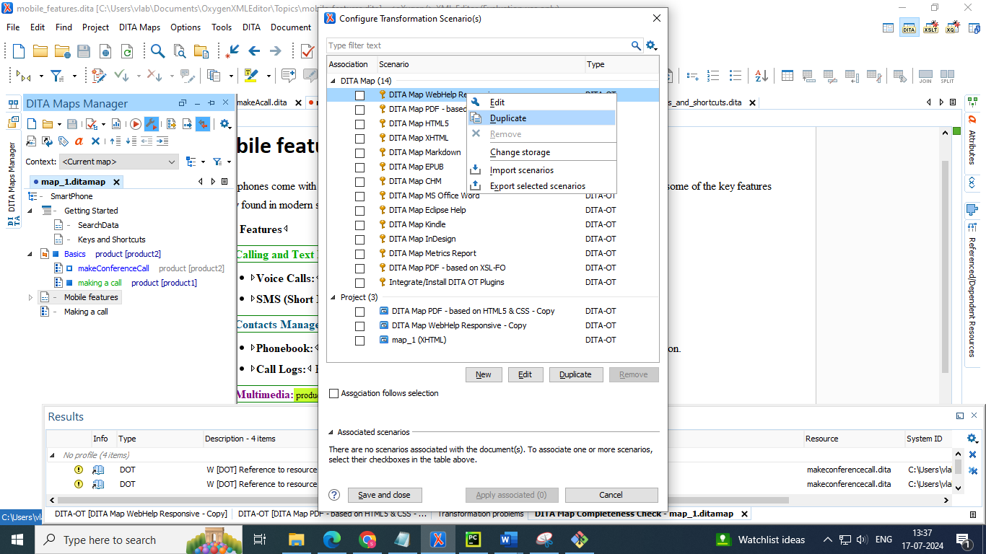

* Go to filter tab 🡪 select the DITAVAL file you want apply

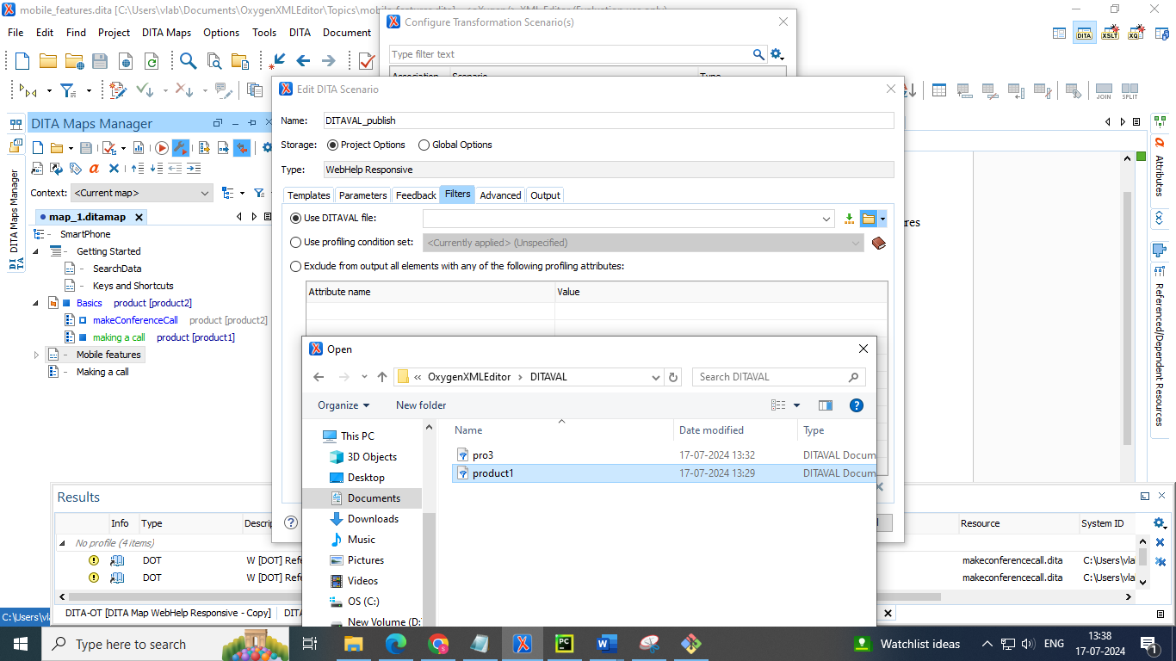

* Go to output TAB and give the required output directory name 🡪 click OK 🡪 publish DITA content

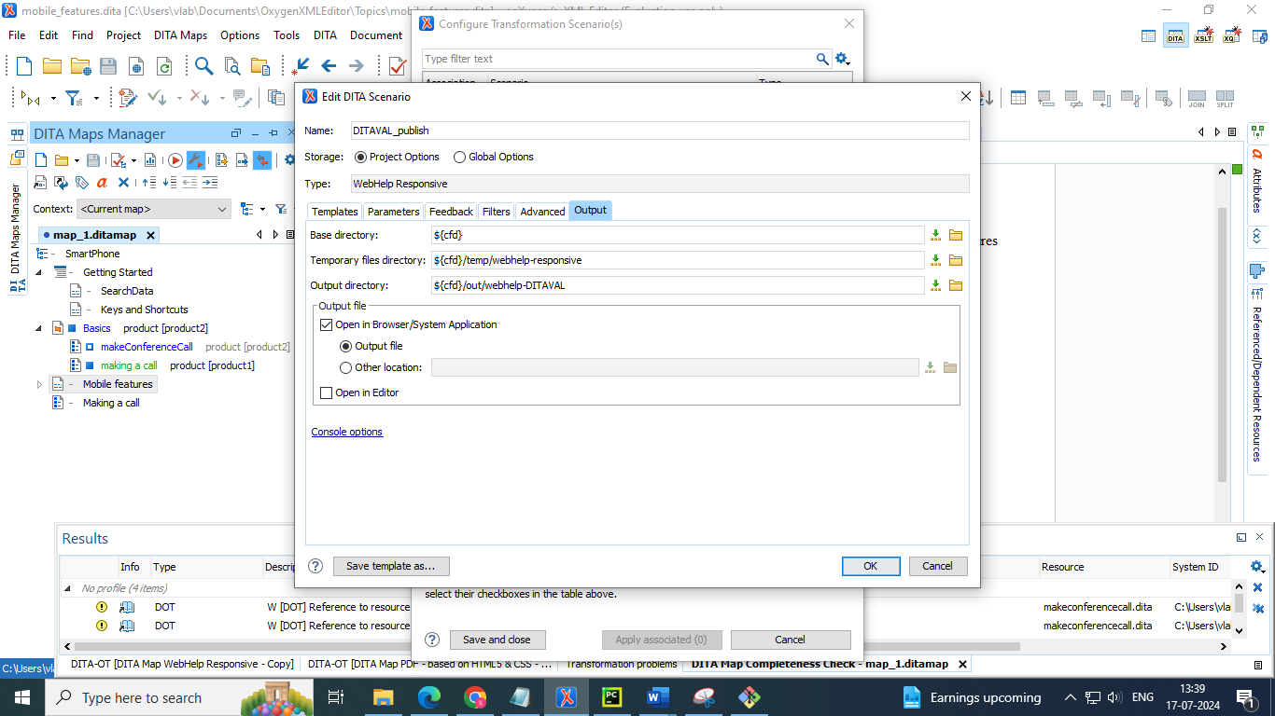

**4. Profiling best practices**

● Take care to limit the complexity of conditions that you apply to content. Context-agnostic writing is often a better approach.

● If a whole topic is to be excluded from the output, profile the topicref, but pay extra attention to its child references.

● Try to profile only block elements or at least whole sentences. Exception: untranslatable constructions such as product names.

● Use minimal styling.

● Use different styles for different attributes (e.g. foregrounds for @audience, backgrounds for @product)

**5. Direct content references**

● Content references are used to pull content from an element in a topic to an element in another topic. Usually the same DITA element is used on both sides of the reference.

● Direct content references are based on file paths and element IDs and are defined using the @conref attribute.

**Steps to Create and Add Content References in Oxygen XML Editor**

**Step 1: Create a Source Topic with Reusable Content**

1. **Open Oxygen XML Editor:**
   * Launch Oxygen XML Editor on your computer.
2. **Create a New DITA Topic:**
   * Go to **File** > **New**.
   * In the **New Document** dialog, select **DITA** > **Topic**.
   * Click **Create**.
3. **Add Reusable Content:**
   * In the new topic, add the content you want to reuse. For example, create a <section>, <paragraph>, or any other DITA element.
   * Save the topic with a meaningful name, e.g., reusable_content.dita.

**Step 2: Reference the Reusable Content in Another Topic**

1. **Open the Target Topic:**
   * Open the topic where you want to insert the content reference.
2. **Insert Content Reference:**
   * Position the cursor where you want to insert the reusable content.
   * Go to **DITA** > **Insert** > **Content Reference** or use the right-click context menu and select **Insert** > **Content Reference**.

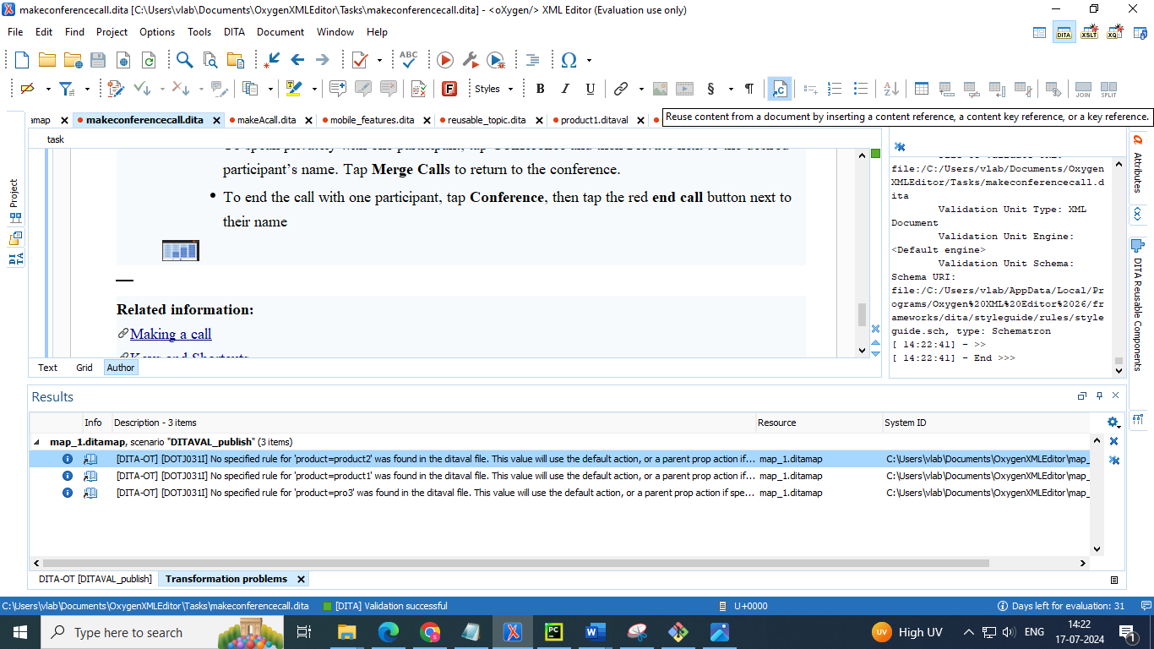

1. **Select the Source File:**
   * In the **Insert Content Reference** dialog, click on the **Browse** button to select the source file (e.g., reusable_content.dita).

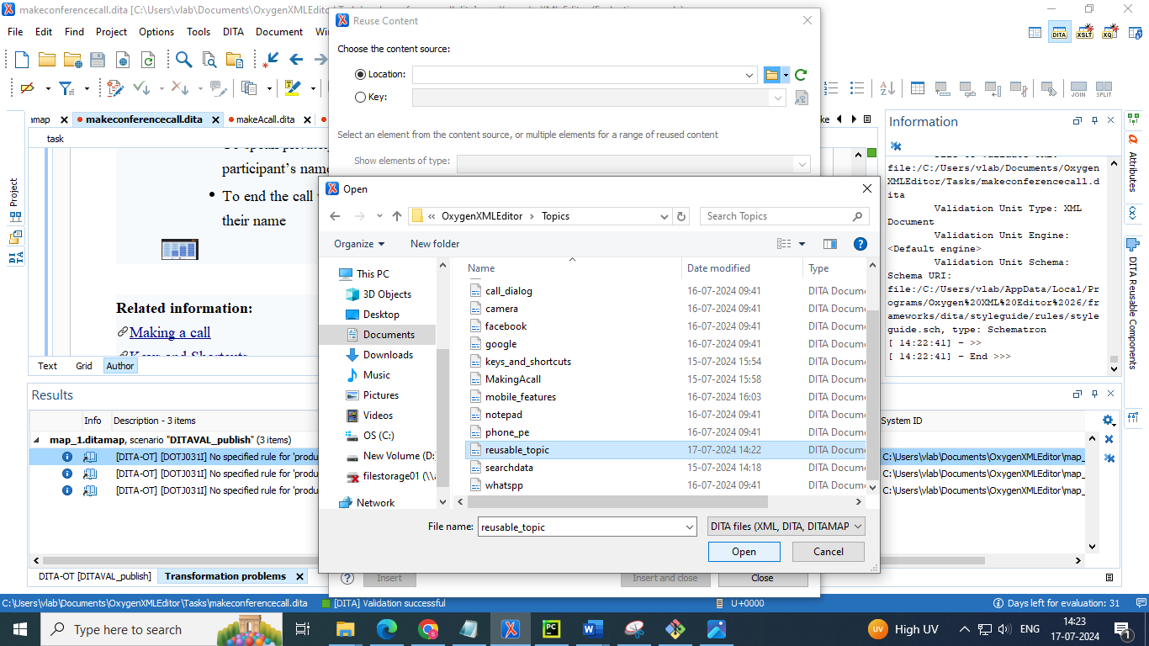

1. **Select the Element to Reference:**
   * In the source file, select the specific element you want to reference (e.g., a <section> or <paragraph>).
   * Click **OK**.

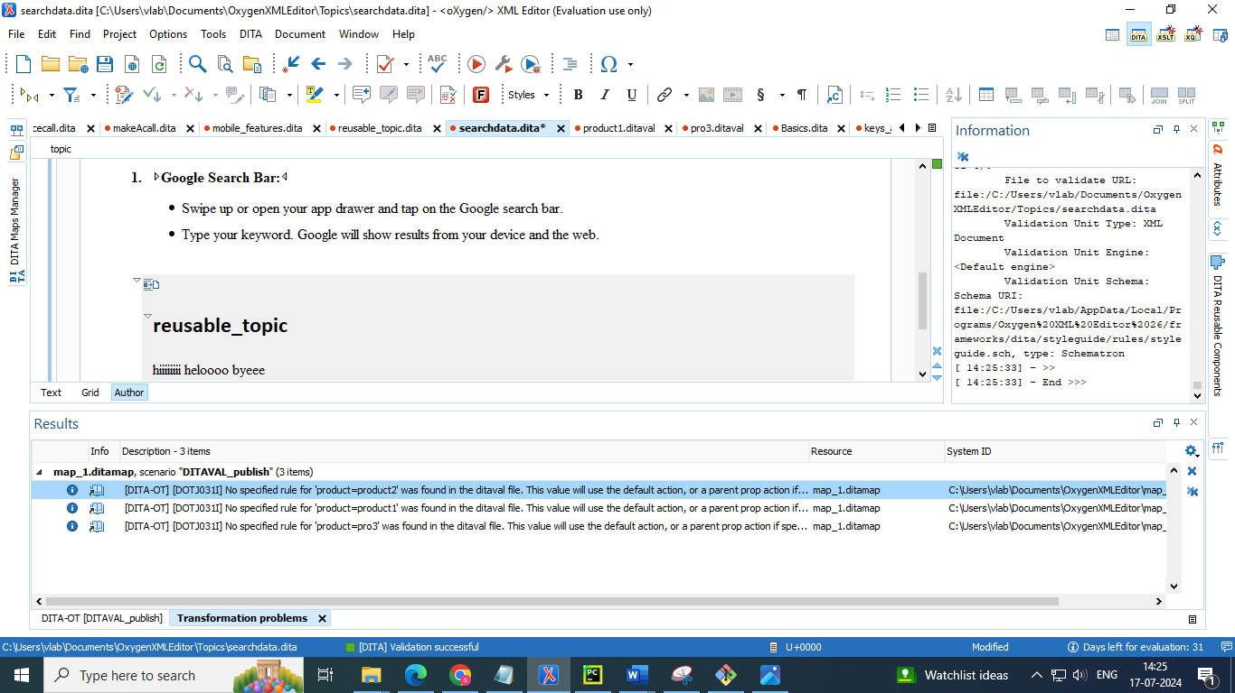

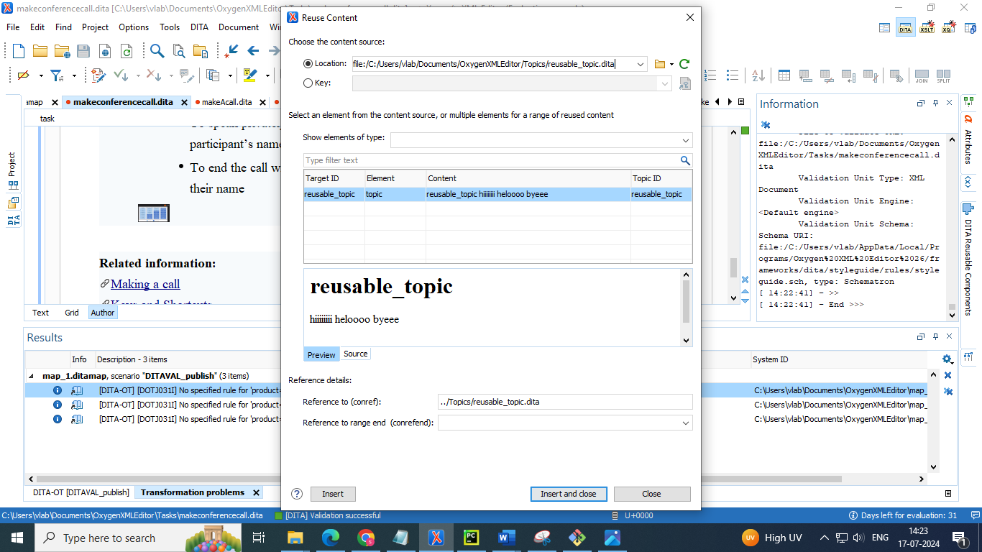

1. **Save the Target Topic:**
   * Save the target topic where the content reference was inserted

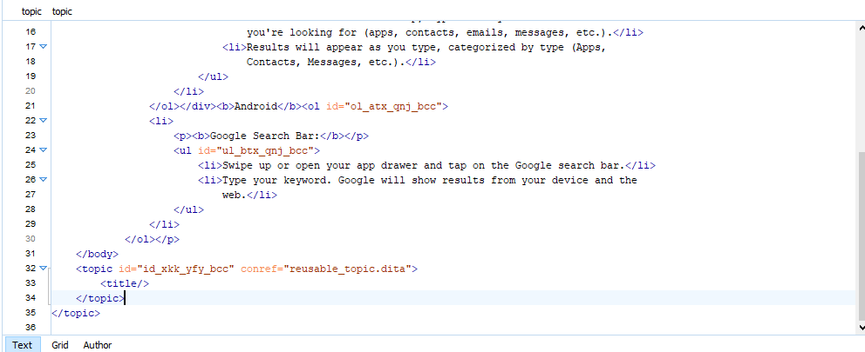

**6. Keys, keyrefs and indirect content references**

● Key definitions bind key names to resources. By saying just key, we usually mean the key name.

● A key reference is a reference to a key (using the key name). Key references are indirect references to resources.

● Indirect content references are based on key names and element IDs, and are defined using the @conkeyref attribute

**Inserting a key**

* Go to DITA map manager 🡪 right click 🡪 select append child 🡪 select key definition

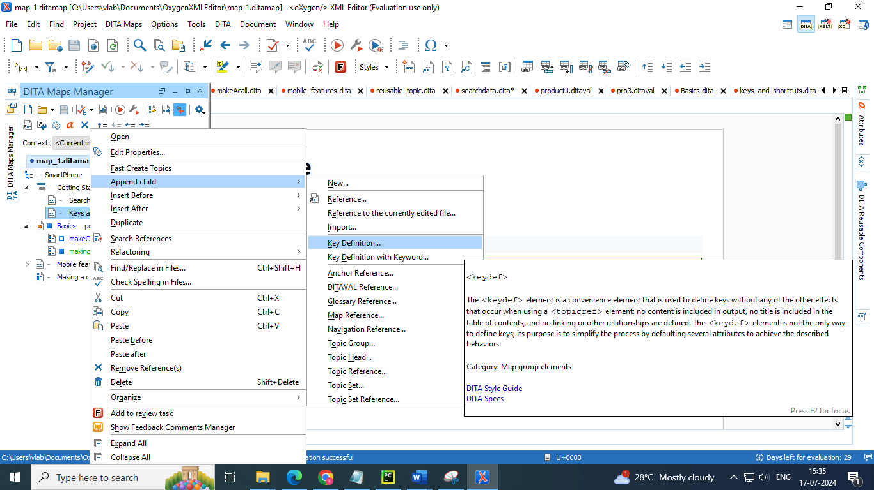

* Its pop up the insert key definition dialog box 🡪 select the target topic to which you want to create the key

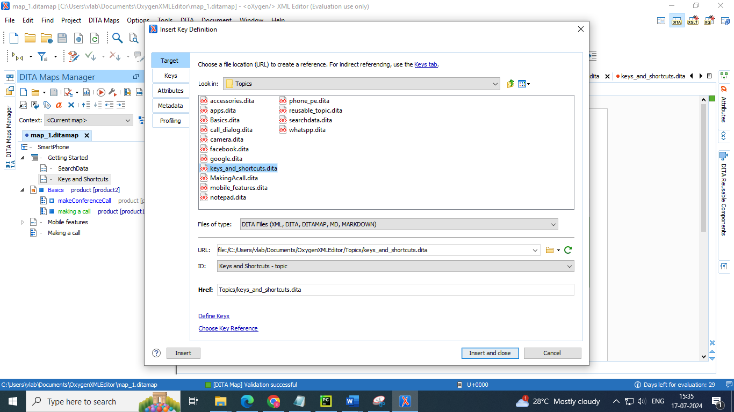

* Go to keys section 🡪 give a name of key which refer to the target topic

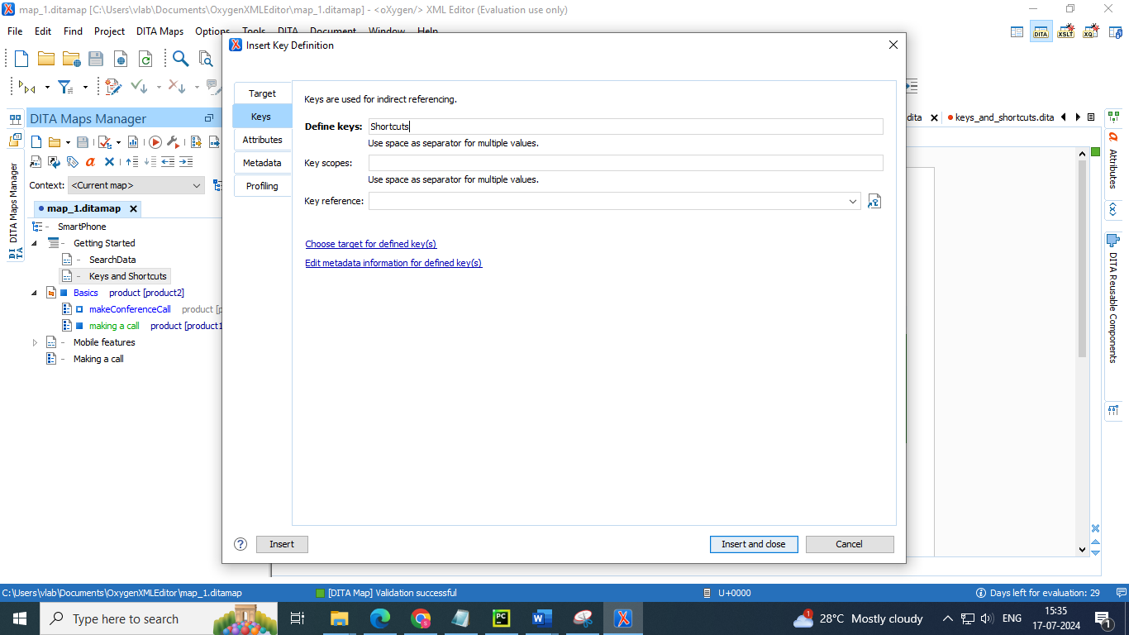

* It creates key which we can view in DITA map manager and topic description

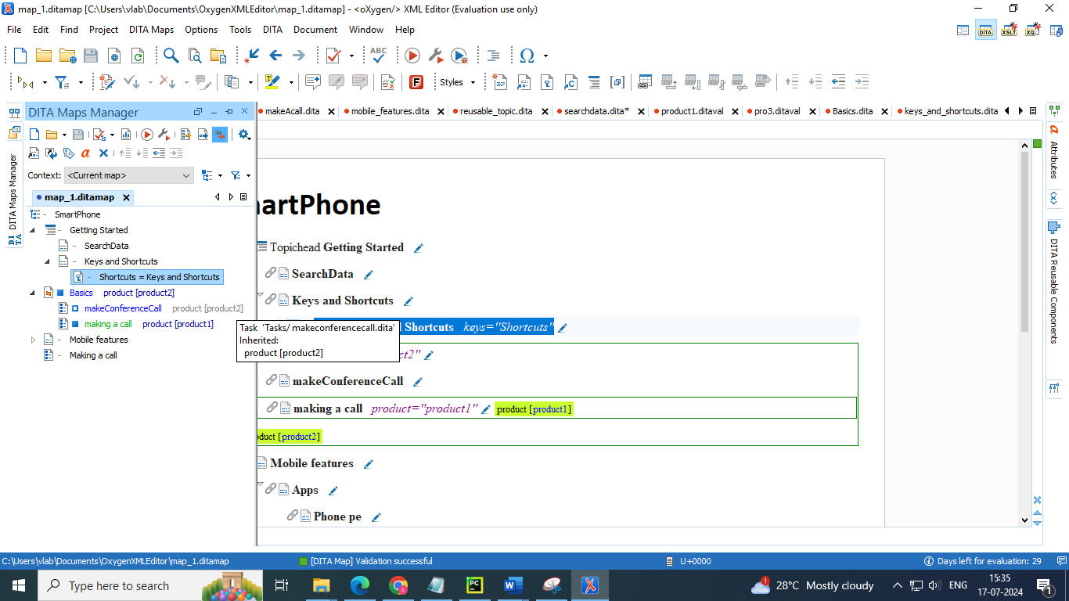

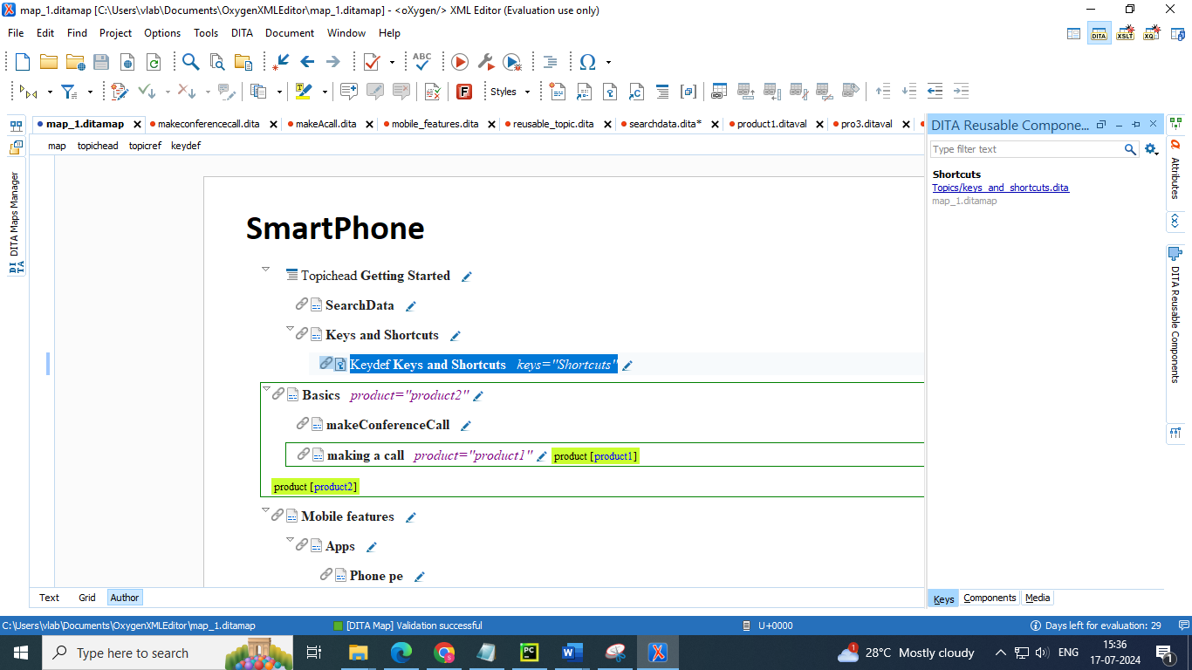

**Inserting a key with keyword**

* Go to DITA map manager 🡪 right click 🡪 select append child 🡪 select key definition with keyword

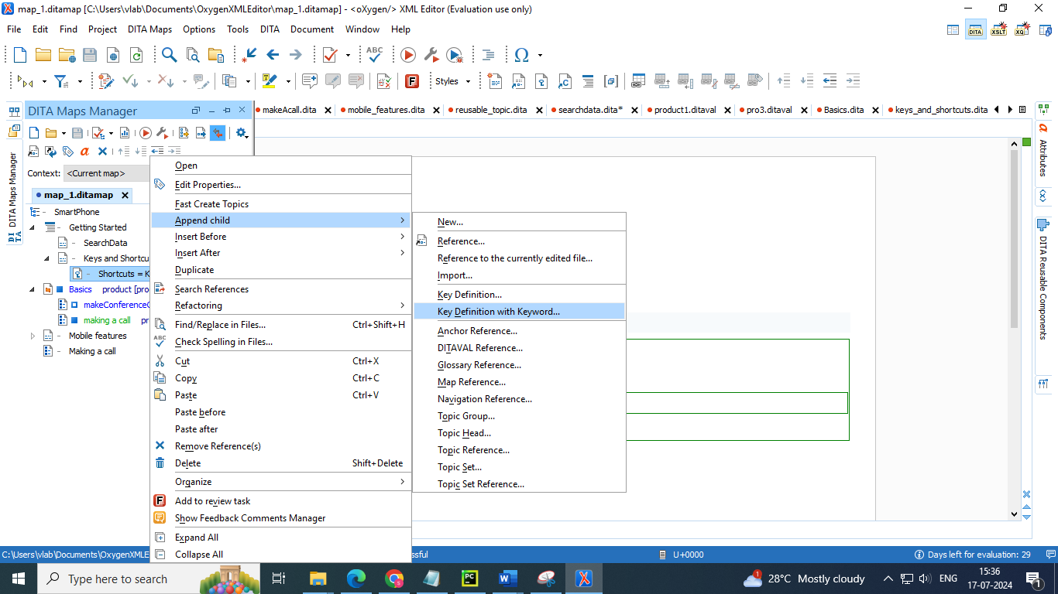

* Enter the key name and its value (keyword)

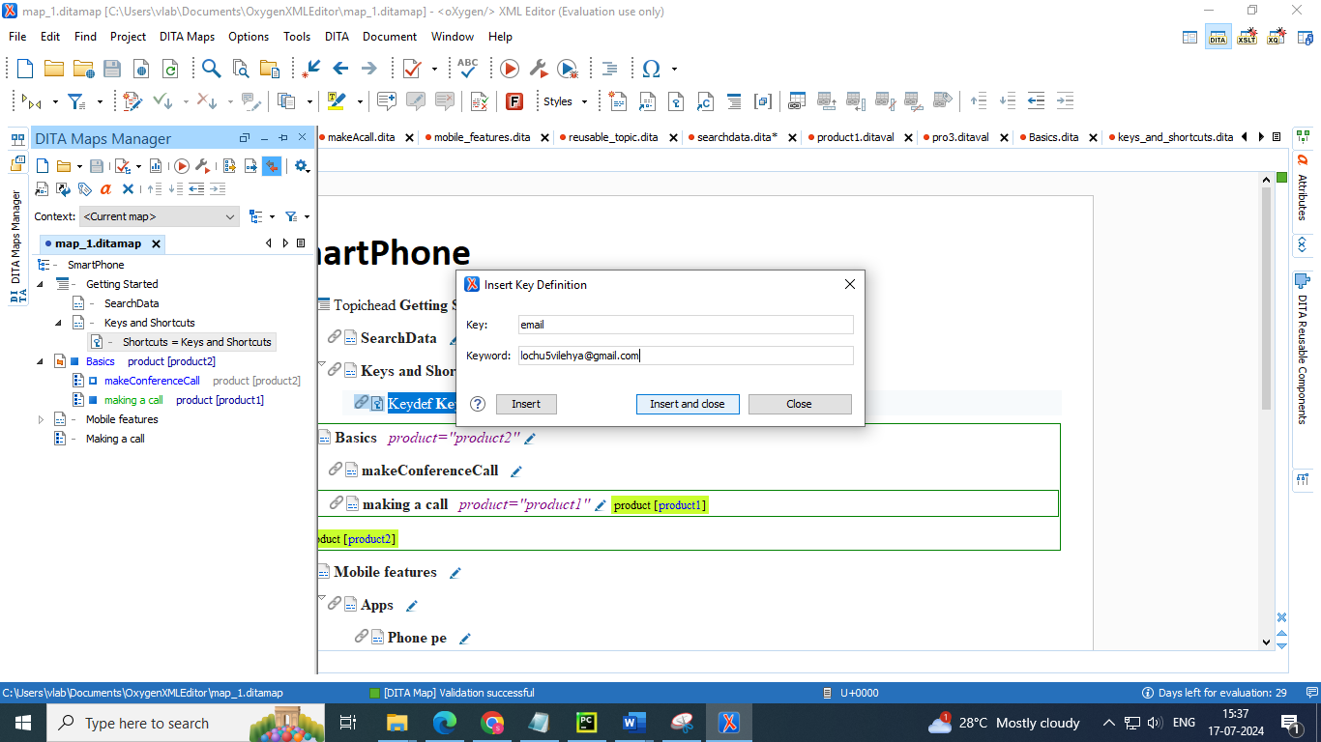

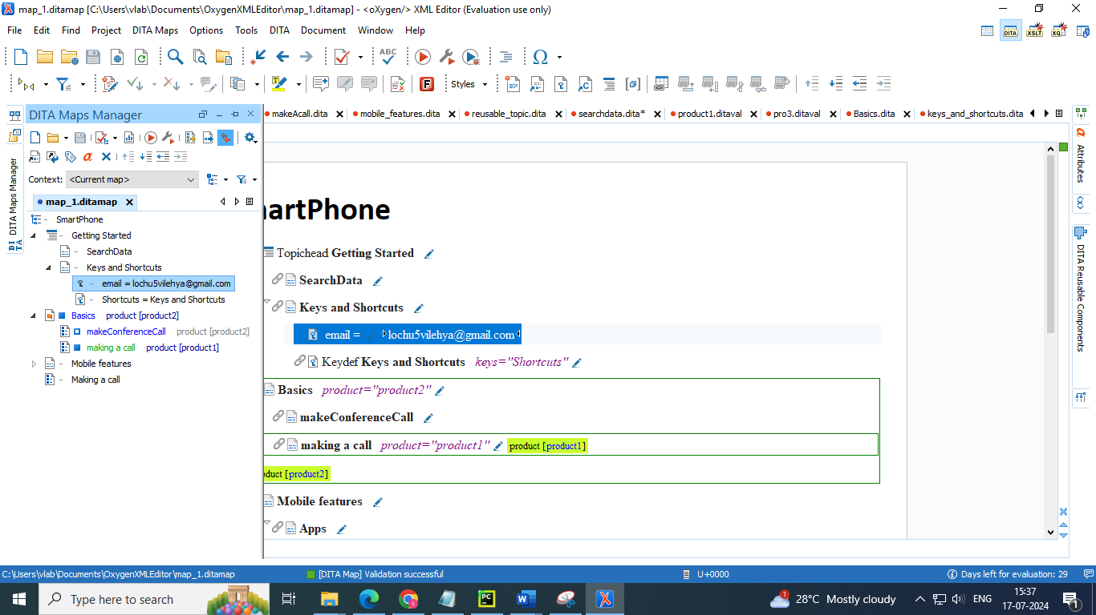

**Insertion of key reference**

* Go to a particular topic 🡪 press enter 🡪 add a para 🡪 add a keyref 🡪 select the key reference from the drop down lists of keys

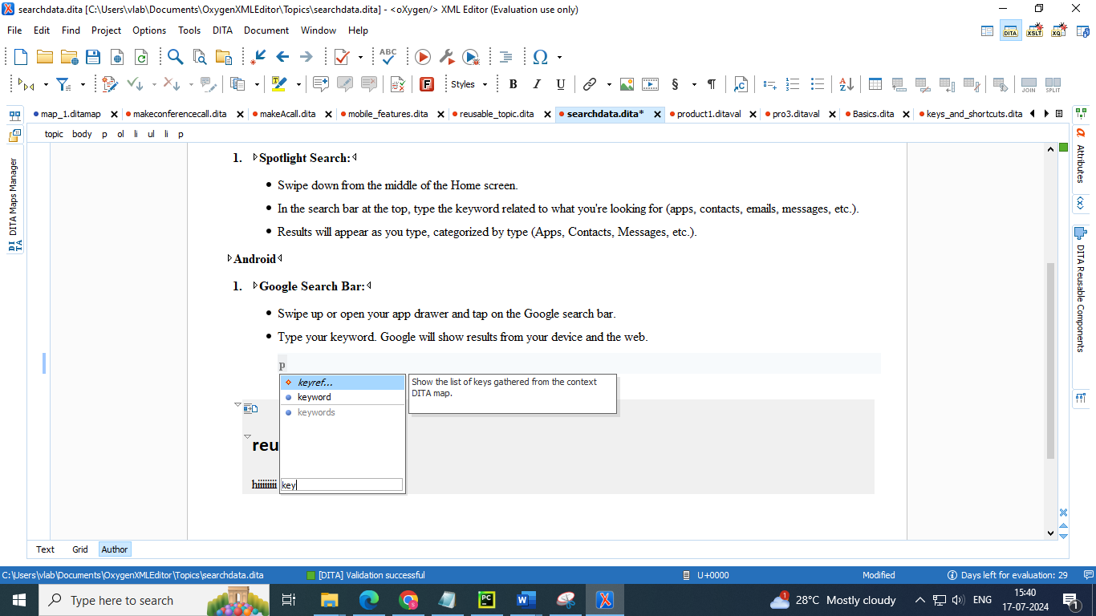

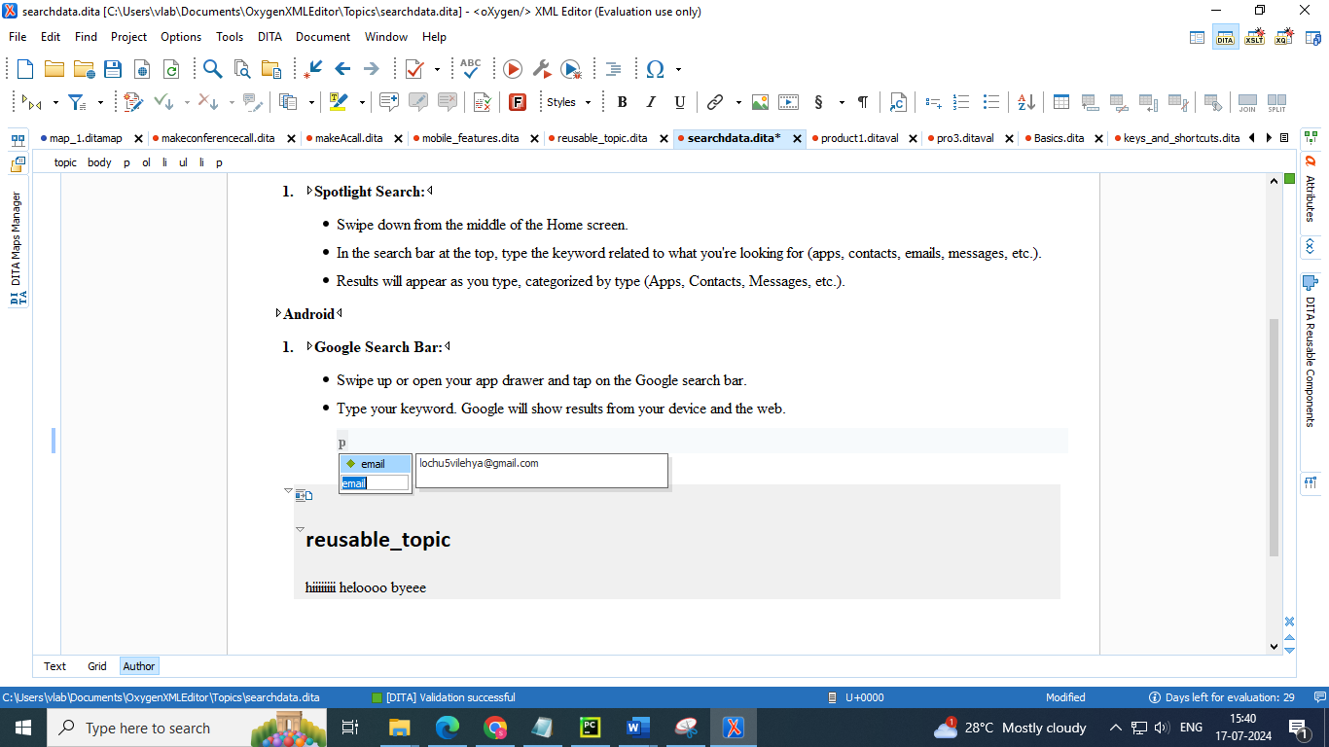

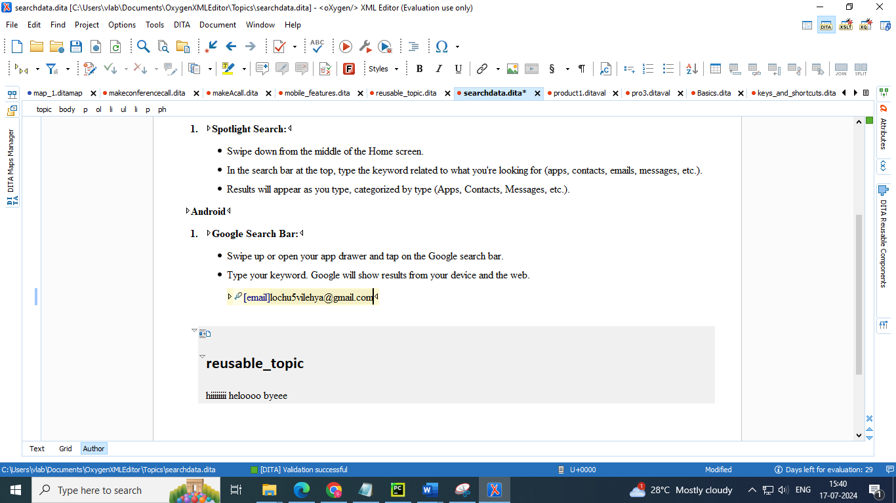

* You can also insert the keys from DITA reusable components 🡪 keys section

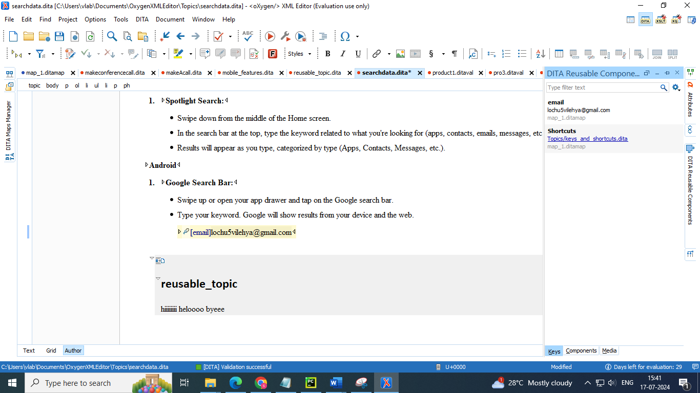

* You can also add key reference by selecting content reference from menu bar 

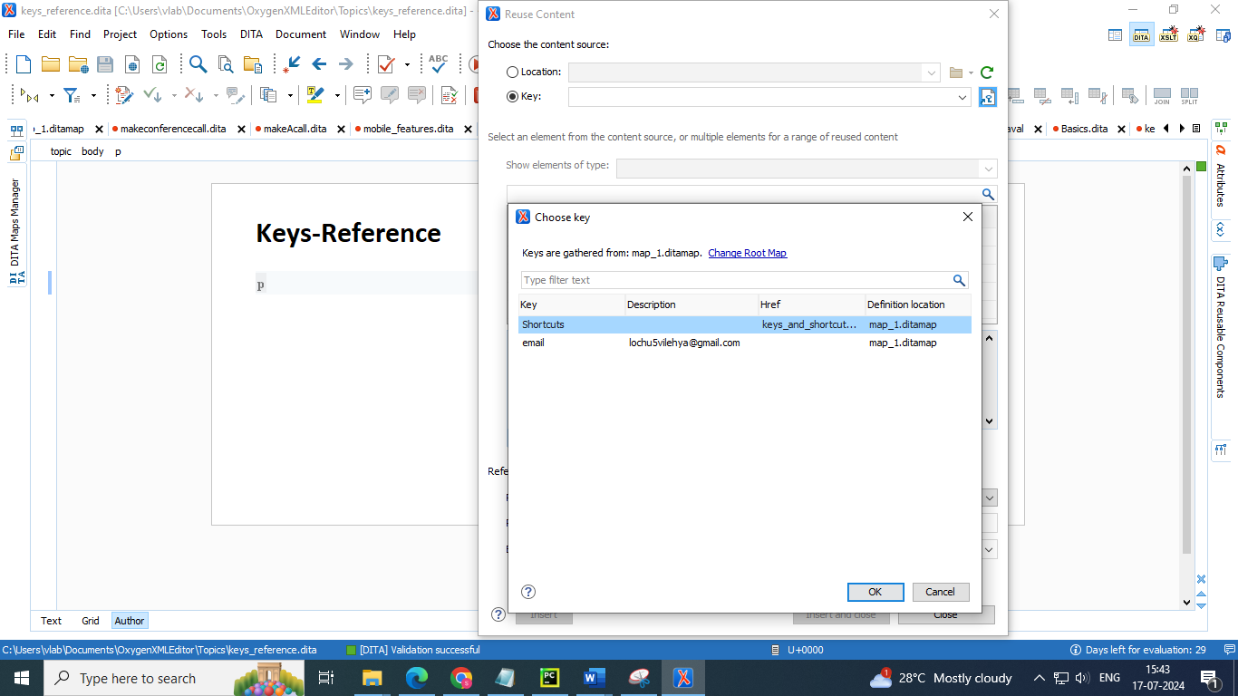

* Select the key you want to add from list below

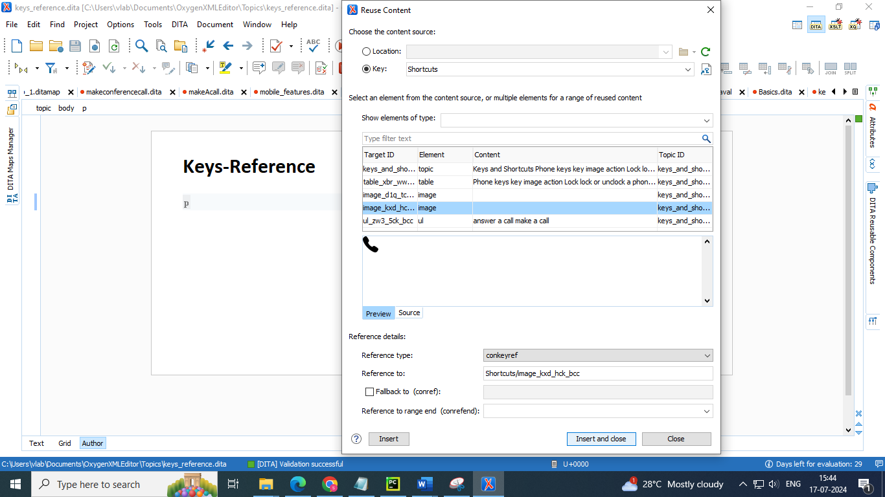

**7. Reuse best practices**

● Use warehouse topics for your reusable components.

● Organize your reusable content. For example, create separate warehouses for product names, images, etc.

● Use naming conventions for IDs, keys, filenames, etc.

● Whenever possible, reuse block elements.

● If you need to reuse content inline, reuse entire sentences only. Exception: untranslatable constructions such as product names